,

FieldLab documentation

User Guide

May 2020

Information and communication technology

Summer project

TABLE OF CONTENTS

1 PREFACE 4

2 REVISION HISTORY 5

3 ROBOTSTUDIO 6

3.1 Install robotstudio 6

3.2 Making a station 6

3.3 Points of possible failure 7

4 OPC – SERVER 8

4.1 ABB IRC5 OPC Server 8

4.2 Using ABB IRC5 OPC Server Configuration 8

5 CONNECTION FROM OPC SERVER TO DATABASE 11

5.1 Install Python and the required libraries 11

5.2 Database configuration 12

5.3 Table creation 12

5.4 Running the Python application 14

5.5 Data from OPC server 16

6 OPENVPN 18

7 CLONE THE GITLAB REPOSITORY 19

7.1 Repositories 19

7.2 Cloning the repository using terminal 19

7.3 To learn more 20

8 SETTING UP THE SERVER 21

8.1 Docker-compose-yml 21

8.1.1 Run the script first 21

8.1.2 Spinning up the containers 22

8.2 Installing with script 24

9 DATABASE 25

9.1 Installation 25

9.2 Database configuration 26

9.3 To allow connection from outside localhost 27

9.4 Creating table in PostgreSQL prompt 28

9.5 Creating table in phpPgAdmin 28

10 GRAFANA 31

10.1 Installing on virtual server 31

10.2 Connecting with PostgreSQL 31

10.3 Add data source 32

10.4 Create a dashboard 34

11 SETTING UP THE REST OF THE VIRTUAL SERVER 37

11.1 Install the Nodejs back-end 37

11.2 Install the React front-end 39

11.2.1 Technologies used 40

11.2.2 Points to consider from the original team 41

12 FURTHER DEVELOPMENT 42

12.1 OPC Server and Python connection 42

12.2 Database/server 42

12.3 Frontend 42

13 CURRENT FRONT-END AND BACK-END 44

13.1 Front-end 44

13.1.1 Main page 44

13.1.2 NavBar 45

14 SOURCES 46

ATTACHMENTS 47

# PREFACE

The purpose of this document is to flesh out the ideas conceived by “Innovaatioprojekti” course, which was done in co-operation with mechanical engineering students. The document aims to give guidance in setting up the system in Gitlab’s virtual server, but only through VPN connection – In real production environments things are rarely so simple.

The environment consists of six separate parts represented in figure 1, which are the ABB IRC5 OPC server, the application that transfers data between the OPC server and the database, the database, server back-end and finally to view the data either web front-end or Grafana.

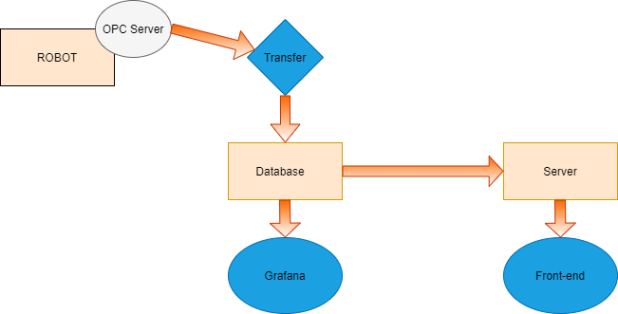

FIGURE 1. The workflow from the robot to the viewer

# REVISION HISTORY

28.05.2020 Git clone through https.

Pm2 startup script.

29.05.2020 Comments to chapter 1

Note about database administration from localhost.

Python application’s documentation (config files).

03.06.2020 Notes on cloning.

Ownership of /react folder.

11.06.2020 Chapter for docker installation and using the bash script.

12.06.2020 Separated cloning into a separate chapter.

18.06.2020 Using the install script

# ROBOTSTUDIO

## Install robotstudio

Download link:

<https://new.abb.com/products/robotics/robotstudio/downloads>

As of May 25th, 2020 the licenses are currently free until the end of the year. School also has a license-server reachable at 195.148.56.223 through VPN-client (See chapter 5).

## Making a station

You can proceed either by using the provided station Dataohjelma.rspag from the projects gitlab repository, which will provide you with several readable signals. Or you could create your own station for which the following links provide some tips.

[Create Station and Robot System](https://www.youtube.com/watch?v=K1W364FYlsM)

[Simple Points](https://www.youtube.com/watch?v=S7OjdnABlUo)

To transfer variables in RAPID make them PERS as in persistent variables as in figure 2.

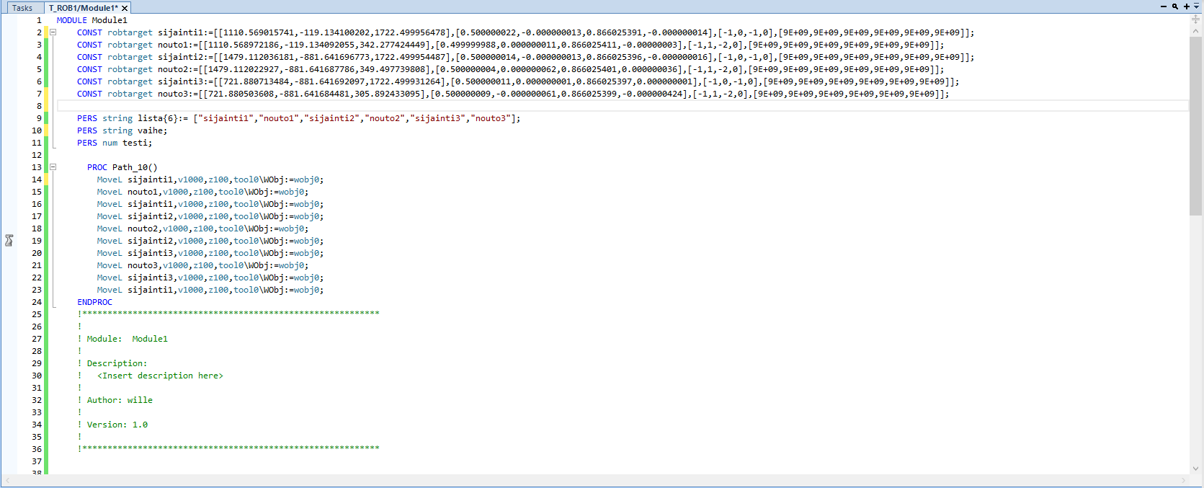

These are example variables

FIGURE 2. Making persistent variables

## Points of possible failure

* Scandinavian characters within your windows paths

# OPC – SERVER

## ABB IRC5 OPC Server

The hardware in this project was TAMK's robot ABB IRB 4600 and the OPC server was ABB IRC5 OPC Server, which can be downloaded from: <https://developercenter.robotstudio.com>.

The ABB IRC5 OPC Server displays OPC items for robots with configured aliases. You must use the ABB IRC5 OPC Configuration tool to create aliases for the robots you wish to monitor. If you do not create any aliases before you launch the browser, you will not see any items in the Data Access namespace. For more information please refer to the [Application manual](http://developercenter.azurewebsites.net/blobproxy/devcenter/Downloads/IRC5_OPC/AM-IRC5_OPC_Server.pdf).

## Using ABB IRC5 OPC Server Configuration

First add a new alias by clicking the “Add New Alias” button as in figure 3.

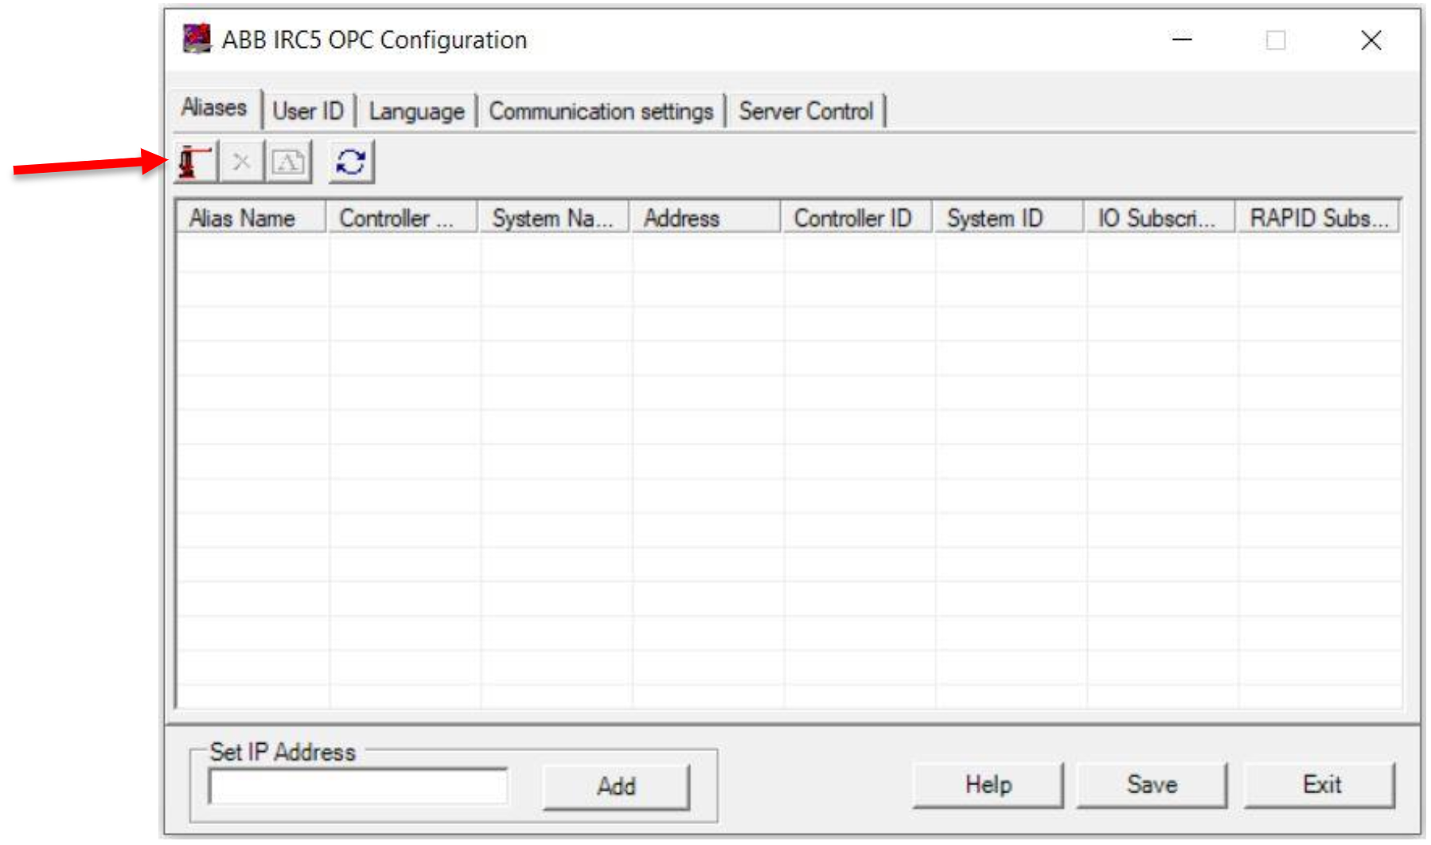

FIGURE 3. Creating a new alias

Next, the window seen in figure 4 will open. Pressing the “Scan” button will allow the application to scan for available controllers.

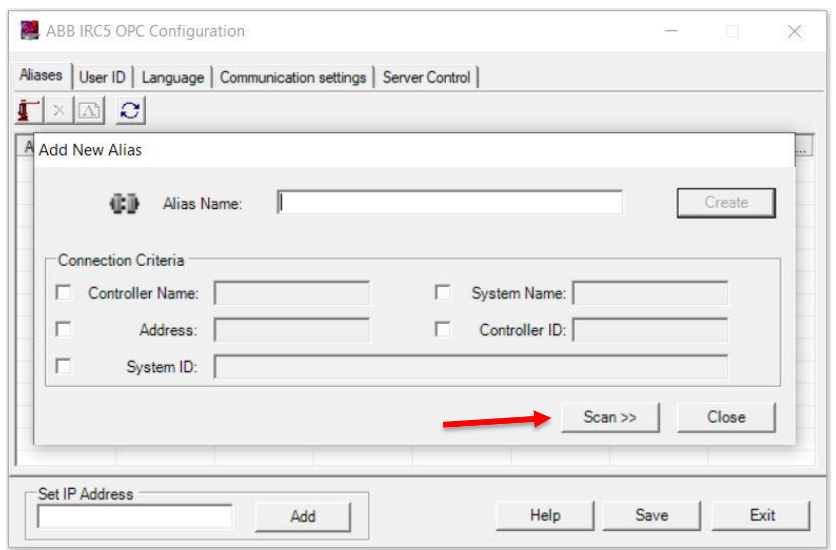

FIGURE 4. Scanning for controllers

After scanning, select the correct robot controller from the list and select the markings as shown in “Connection Criteria” as in figure 5. Then press the “Create” button to create a new alias.

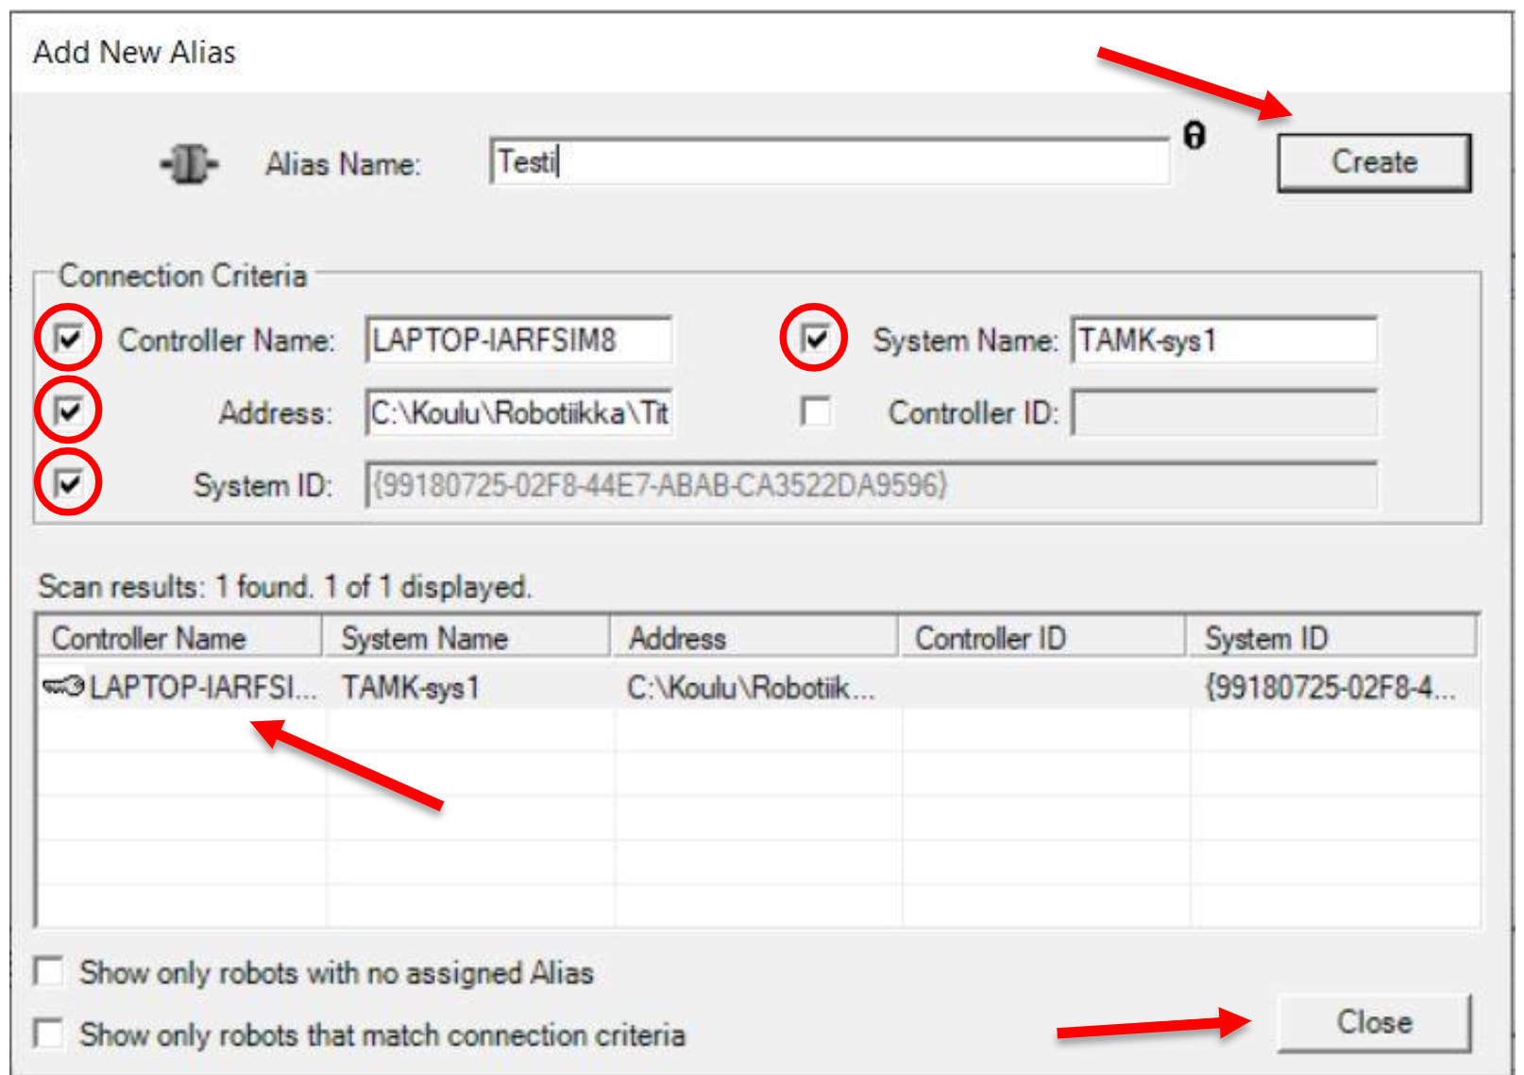

FIGURE 5. Connection criteria

In “Server Control” click the “Start” button and OPC server starts. After starting the server can be stopped by pressing “Stop” seen in figure 6.

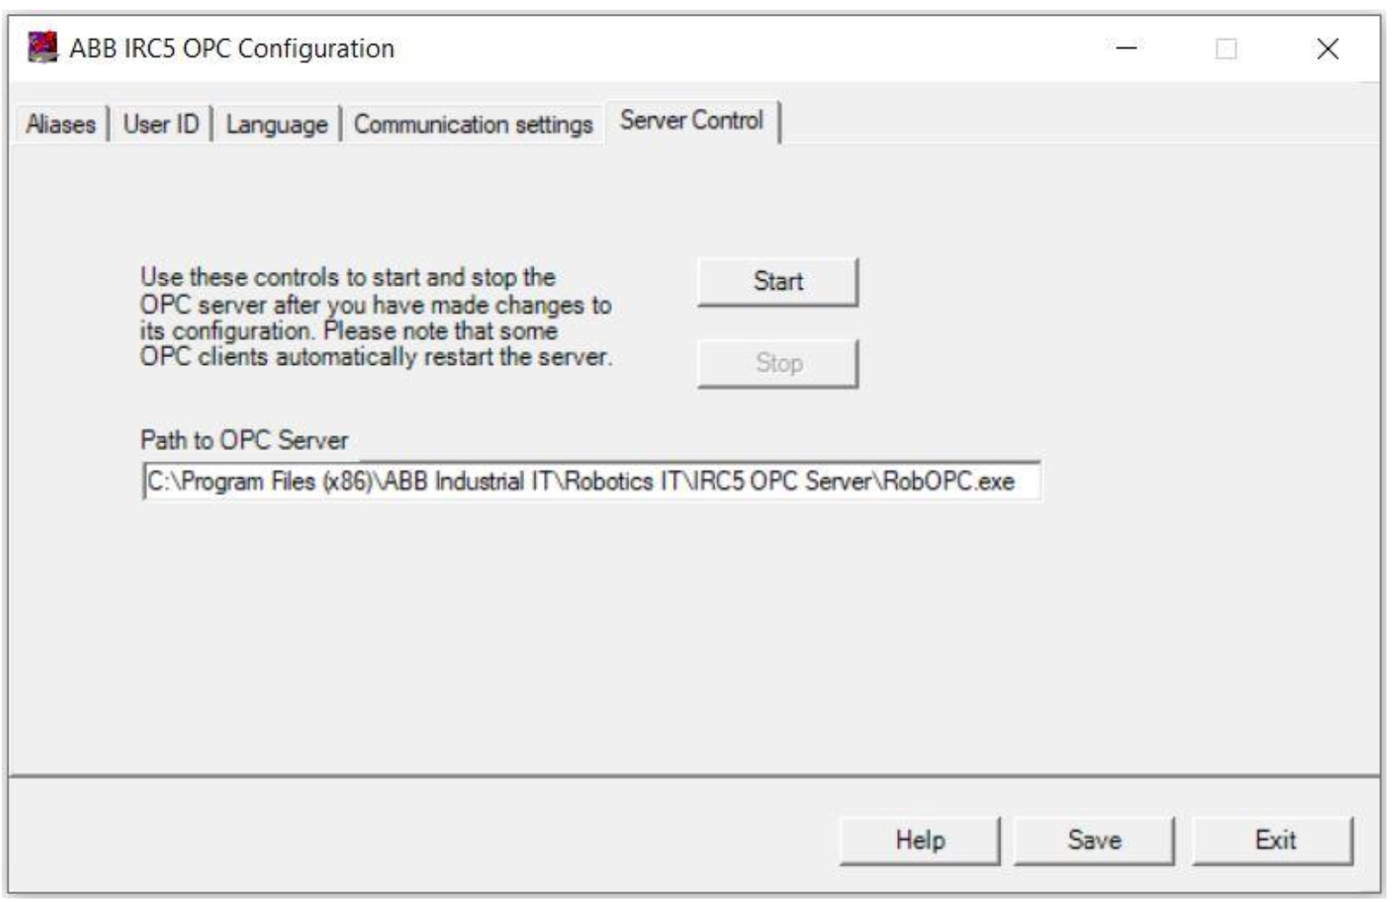

FIGURE 6. Starting/stopping the server

# CONNECTION FROM OPC SERVER TO DATABASE

To transfer data from the OPC server to the PostgreSQL database, separate application is required. The current application can be found from the projects gitlab [repository](https://gitlab.tamk.cloud/tamk-projects/robot-innovation-project/-/tree/master/opc-datafetch). This is purely win-application, so do not try to use these libraries with mac or linux, unless you’re absolutely sure you know what you’re doing.

## Install Python and the required libraries

All the necessary files can be found in the repo under [opc-datafetch/installations](https://gitlab.tamk.cloud/tamk-projects/robot-innovation-project/-/tree/master/opc-datafetch/installations):

1. Install 32-bit python 3.6.x

2. Install pywin32 -> for python 3.6 32-bit

3. Install DLL library (figure 7)

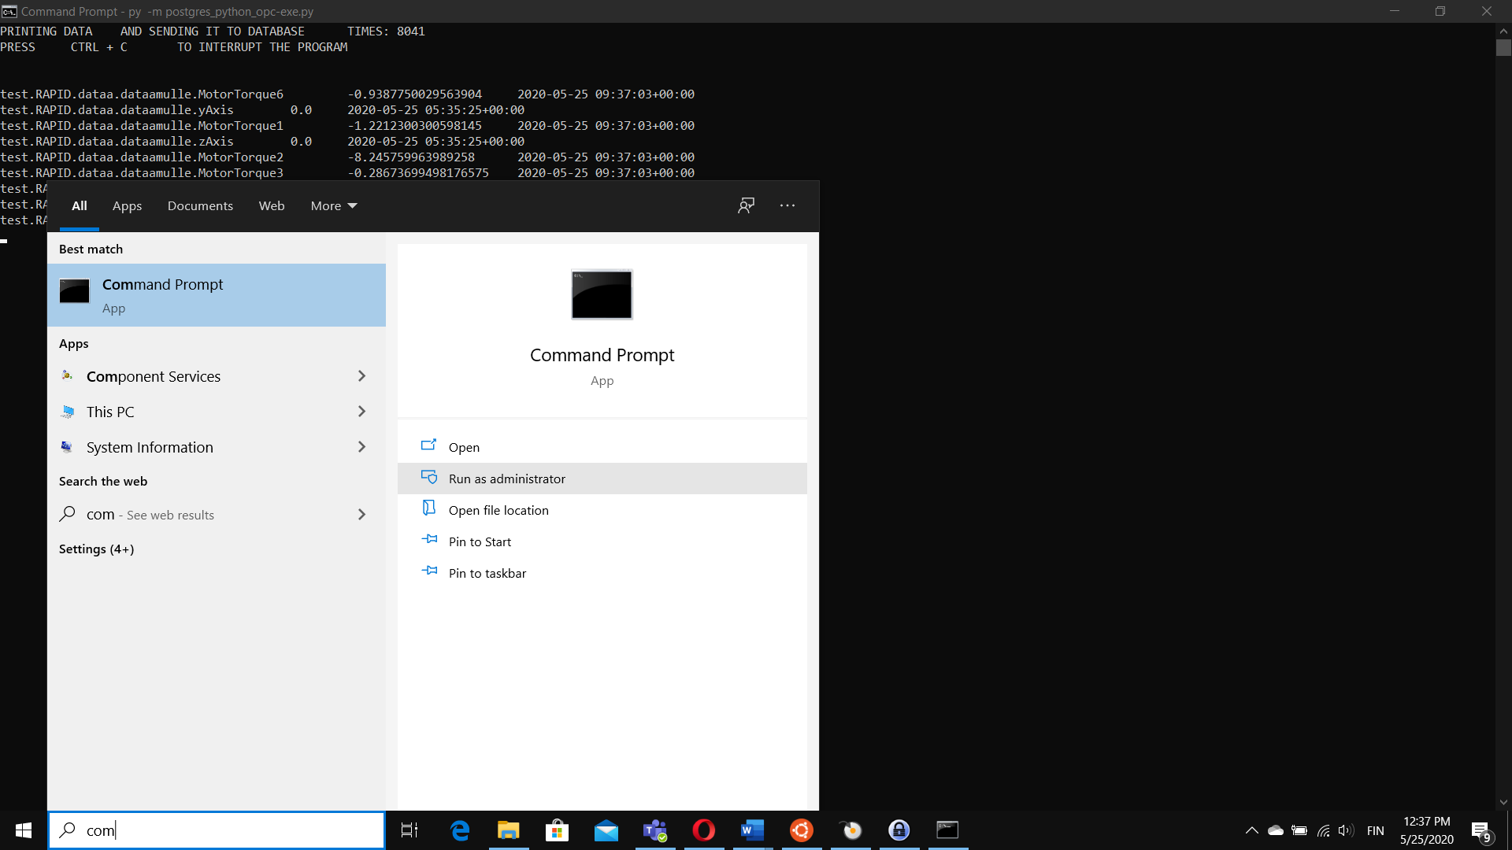

FIGURE 7. Win command prompt as admin in directory where the file is located *regsvr32 gbda_aut.dll*

4. Install OpenOPC using python prompt

*pip3 install OpenOPC-Python3x*

alternative #1 *pip install OpenOPC-Python3x*

alternative #2 *py -m pip install OpenOPC-Python3x*

## Database configuration

In order to push data to the database, the database has to be properly configured. The python program is using the following defaults, which should be edited when necessary:

Database name test_db

Tablename robottidata

Username postgres

Password Robotti123

Port 5432

IP 172.16.4.134

The table used has four columns as in table 1.

TABLE 1. Columns and their names for robottidata

|  |  |  |  |
| --- | --- | --- | --- |
| NAME | VALUE | QUALITY | TIME |
| MotorTorque1 | -1.9849238492 | Good | 2020-05-25… |

## Table creation

The table can be created either by using databases own tools or by using python according to the following instructions.

1. Install the necessary libraries *pip3 install psycopg2*

Alternative #1 *pip install psycopg2*

Alternative #2 (Win prompt) *py -m pip install psycopg2*

2. importing psycopg2 (python prompt) *import psycopg2*

3. Creating connection

(in python cli) *conn = psycopg2.connect(database="test_db", user="postgres", password="Robotti123", host="172.16.4.134", port="5432")*

*cur = conn.cursor()*

4. Creating table to PostgreSQL

(in python cli) *create_table_query = '''CREATE TABLE public.robottidata*

*(value double precision,*

*name text COLLATE pg_catalog."default",*

*quality text COLLATE pg_catalog."default",*

*"time" timestamp without time zone); '''*

*cursor.execute(create_table_query)*

*conn.commit()*

5. Test database *sql_test=f"INSERT INTO robottidata (name, value, quality, time) VALUES ('test', 1.00, 'yup_test', '2020-01-01 00:00:00')"*

*cur.execute(sql_test)*

*conn.commit()*

## Running the Python application

The program’s config.ini file contains the default parameters used by the application as in figure 8. Before running the application, modify the values to correspond to your system

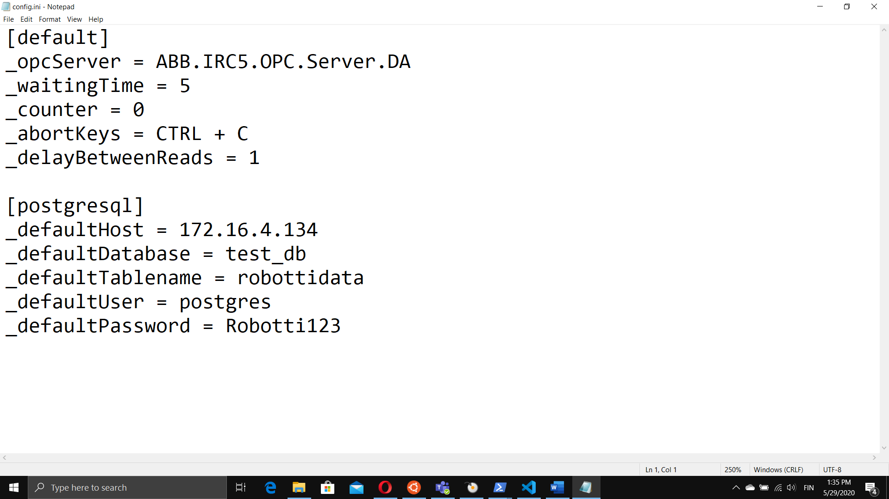

FIGURE 8. Default parameters

You can run the program from command prompt by executing the command:

Win command prompt *py -m postgres_python_opc.exe.py*

PowerShell *python postgres_python_opc.exe.py*

The program asks for the pertinent information, but iyour config.ini-file provides defaults as in figure 9.

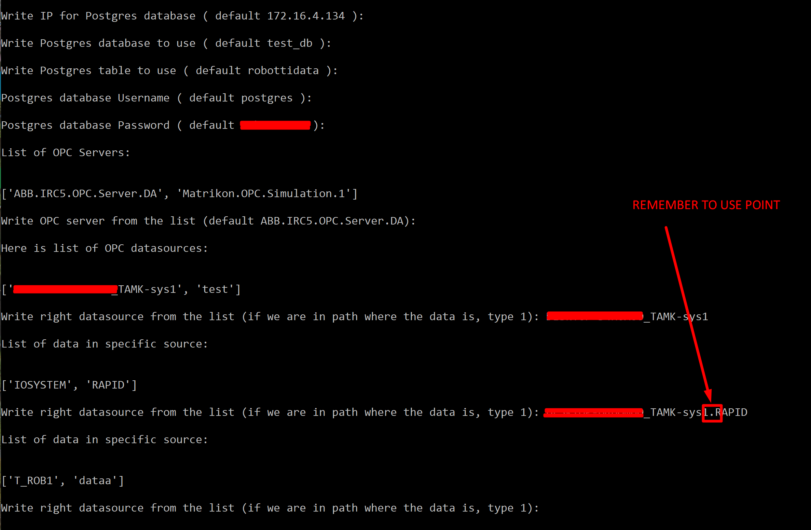

FIGURE9. The program input

When the right data source with the signals needed has been chosen, enter 1 as in figure 10.

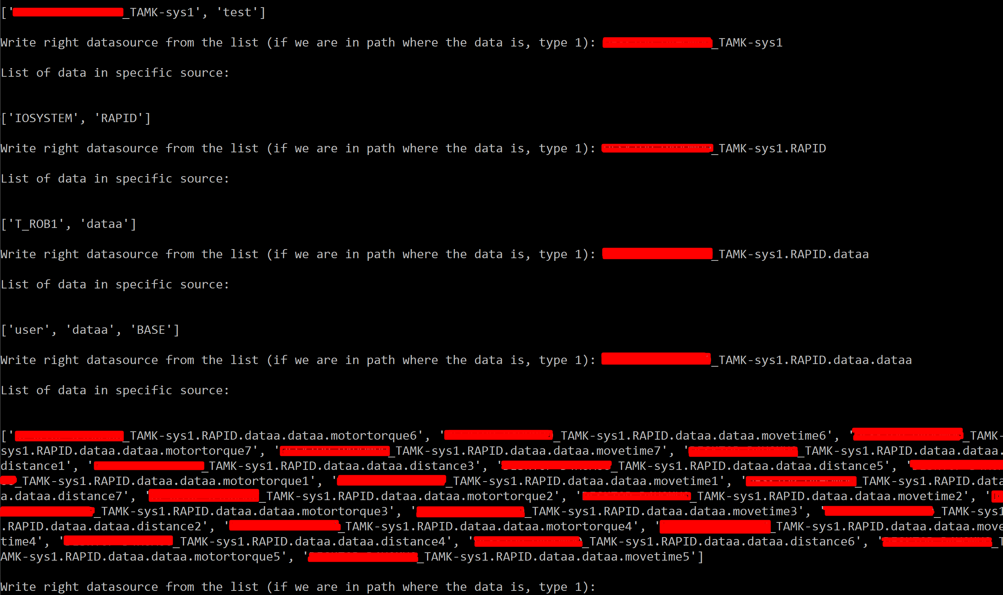

FIGURE 10. Data sources found

If the program functions properly the screen will look similar to that in figure 11.

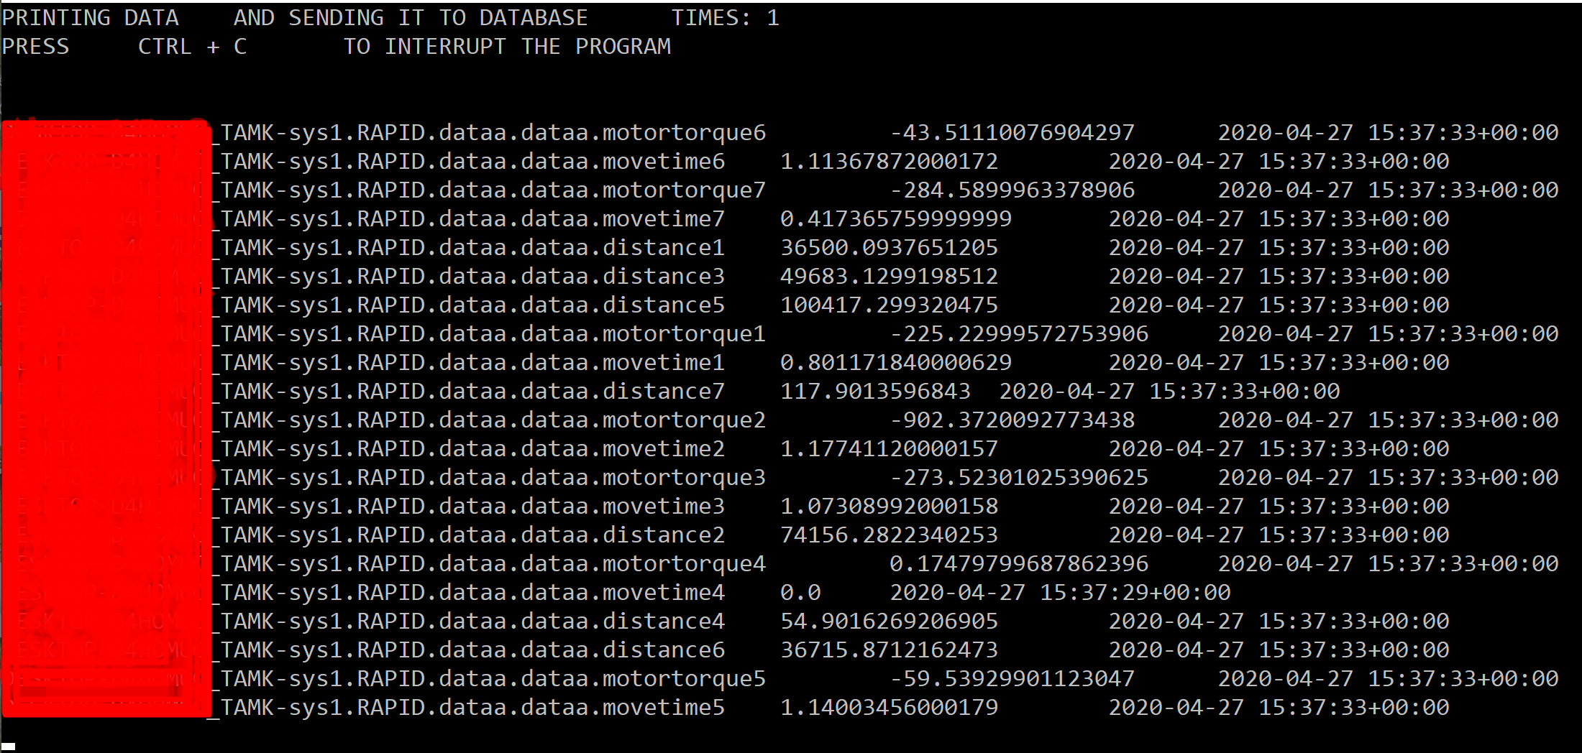

FIGURE 11. Datapoints printed to the screen

You can achieve the same result from python shell, stepping through the commands from the program one by one. This could be useful in debugging the program in error situations.

Step-by-step *import OpenOPC*

*import time*

*import pywintypes*

*import datetime*

*pywintypes.datetime = pywintypes.TimeType*

*opc=OpenOPC.client()*

*opc.servers()*

*opc.connect('SERVER_NAME')*

*opc.list()*

*opc.list('ROBOT_NAME')*

*opc.list('ROBOT_NAME.SUBDIRECTORY.ETC')*

## Data from OPC server

To test connection between database and the python application, you should be able to find the datapoints from the table in question. If you’ve installed the database on virtual server:

1. SSH into virtual server *ssh user@172.16.4.xxx*
2. Access the PostgreSQL prompt *sudo -u postgres psql*
3. Change into correct database *\c test_db postgres*
4. Create query *SELECT * FROM robottidata;*

Or alternatively you could you [PgAdmin](https://www.pgadmin.org) or other similar database management tool and make a query similar to the one in figure 12.

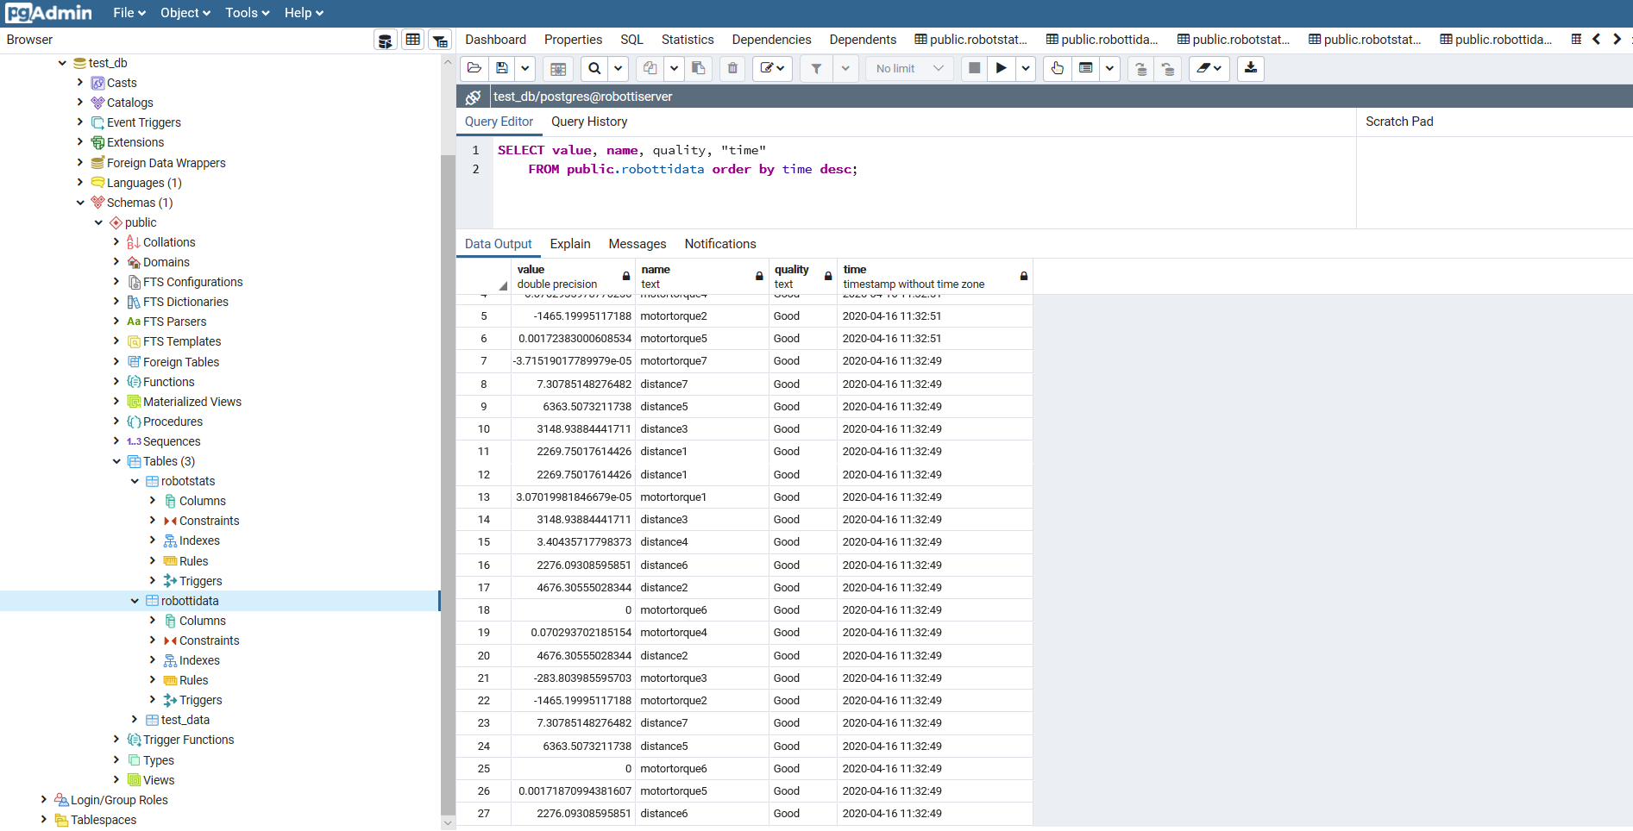

FIGURE 12. Query tool in PgAdmin

Or even something simple like:

*SELECT * FROM public.robottidata*

# OPENVPN

To access everything set up on virtual machines hosted by Titeverkko requires a VPN connection outside of Source’s wlan. Please refer to [Gitlab's documentation about setting up the connection](https://gitlab.tamk.cloud/examples/gitlab-guide-wiki/-/wikis/student-vpn-fi).

# CLONE THE GITLAB REPOSITORY

Everything related to this project is available from a Gitlab repository. Of the following repositories or repos as they’re usually called, the top one is the most current and rest are either related to the systems older versions or some specific aspect of the project.

## Repositories

[0026 RobotLab IoT ML](https://gitlab.tamk.cloud/tamk-projects/summer-projects/2020/0026)

[0025 OPC DA UA Making](https://gitlab.tamk.cloud/tamk-projects/summer-projects/2020/0025)

[robot-innovation-project](https://gitlab.tamk.cloud/tamk-projects/robot-innovation-project)

Accessing these repos requires the use of a VPN-connection and suitable access rights provided by the owners/maintainers of the repos. This documentation assumes that you’re installing the system on a TAMK’s virtual machine.

## Cloning the repository using terminal

You can clone the projects repository into the virtual server by selecting from the repo clone like in figure 32:

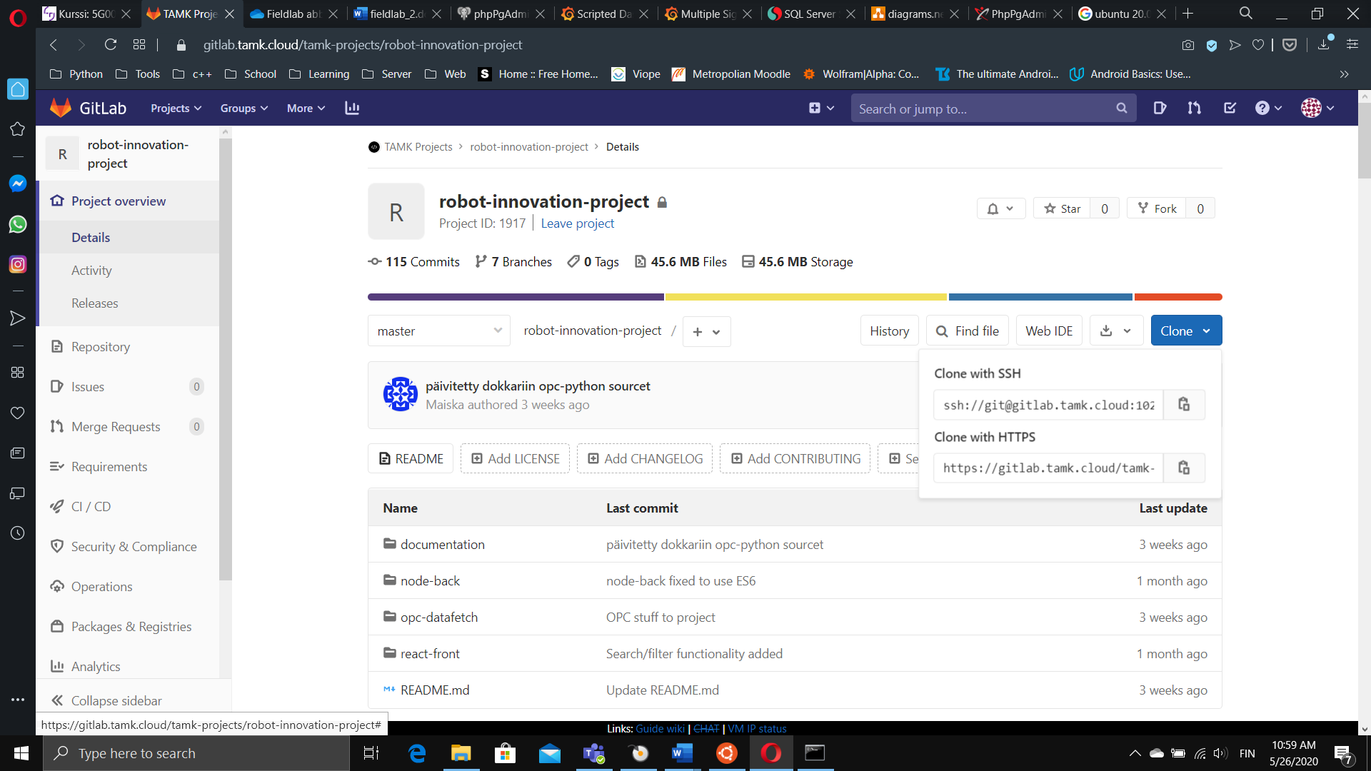

FIGURE 32. Cloning from gitLab

And after logging into your virtual server through ssh, you can clone the repo either through ssh:

*git clone ssh://git@gitlab.tamk.cloud:1022/tamk-projects/robot-innovation-project.git*

TAKE NOTE! To make use of ssh, you’ll have to set-up ssh keys as instructed in [gitlab’s documentation](https://docs.gitlab.com/ee/ssh/).

or through https:

*git clone https://gitlab.tamk.cloud/tamk-projects/robot-innovation-project.git*

TAKE NOTE! You’ll be asked for your login credentials to gitlab.

The cloning might require sudo access depending on which directory you´re cloning the project into.

## To learn more

If you aren’t developing the system, you don’t have to know anything else about how gitlab or git in general work. If you want to learn more, please visit:

[GitLab basics guides](https://docs.gitlab.com/ee/gitlab-basics/)

# SETTING UP THE SERVER

To install the system, you have a couple of options – the first and easiest way is to utilize docker. The second way is to use the installation script provided, and finally you can of course install everything by hand. All of these methods are quite straight-forward but each one of them has their own stumbling blocks. It’s is recommended to use docker for it’s portability and accessability.

This chapter is divided into two distinct parts of which the first discusses the docker option and the second part is related to the bash script. Both of these have been configured to use the exact same default values as elsewhere in this documentation, but you’re more than free to make changes according to your needs and specifications.

The rest of the documentation following this chapter from chapter 9 onwards are either related to the installation by hand or observations from the developers.

## Docker-compose-yml

Docker make it possible to package software into standardized units for development, shipment and deployment. Containers isolate the software from the environment, making it independent of the infrastructure used. To learn more about the technology visit <https://www.docker.com>.

Everything related to using docker can be found from the directory “container”.

Before using the containers provided, make sure you have docker and docker-compose installed on the machine running the container. These instructions are simplified and aimed for total newbies.

### Run the script first

Before starting docker containers, you’ll have to modify the configuration files of both the nodejs and the react apps to reflect the fact, that they’ll be running inside containers with their own internal networks. To simplify this, you’ll find a shell script within the container folder, which will alter those configuration files for you.

To run the runFirst.sh script:

1. change directory *cd container*
2. make sure the script is executable *chmod +x runFirst.sh*
3. run the script *./runFirst.sh*

For simplicity, this assumes that you’ve cloned the project into your home directory. Otherwise, sudo access will be probably be required.

### Spinning up the containers

To start the system after altering the config files, test the system by entering command:

*docker-compose up*

The docker images needed will be downloaded onto the machine and both api and webapi will be built. The docker-compose.yml file contains the necessary files and configurations to initialize the database with the defaults used in this documentation. Persistent storage is also created for both the database and Grafana.

If everything worked as planned, you’ll have the system running on the virtual machine and the first thing is to test that everything is running as planned. Using your browser visit all the following ports of your virtual machine:

172.16.101.131:8080 [Adminer](https://www.adminer.org) – you should be able log in with default username **postgres** and password **Robotti123.** Check that the table test_db has been created and that its content matches the requirements.

172.16.101.131:3000 [Grafana](https://grafana.com) – you should be able to login with the default username **admin** and password **admin**. See chapter 10 for information.

172.16.101.131:9080 Node api – you should receive hello message from the api.

*TAKE NOTE! The node version this is based on, is intentionally older to solve certain incompatibility issues with database access*.

172.16.101.131:3100 React-front – You should be able to access the page.

To stop every container just press CTRL+c.

If everything went fine, you should run the containers detached, so you’ll be able to access the terminal at the same time:

*docker-compose up -d*

You can stop and start the containers by issuing the commands:

*docker-compose stop*

*docker-compose start*

If you wish to remove the containers:

*docker-compose down*

If either the nodeapi or the react app have been altered you’ll have stop the containers and build these with:

*docker-compose -build*

*docker-compose up -d*

## Installing with script

The installation script can be found from the repos ´script-install’ folder.

You’ll have to launch the script with sudo rights:

1. change directory *cd container*
2. Run the script *sudo ./install.sh*

The sudo password is the same password you use to sign-in. This enables certain rights for the script that it requires. To learn more about the sudo and access rights, read [Howtoforge's beginners guide to sudo.](https://www.howtoforge.com/tutorial/sudo-beginners-guide/)

As mentioned earlier, the script uses the defaults used in this documentation, altering only the IP address in the configuration files. If the configuration files in the repo are altered before using this script, the script needs to be modified accordingly.

After running the script, you should be able to test the system using your browser.

# DATABASE

[PostgreSQL](https://www.postgresql.org) is the database used in this project.

## Installation

The database could be installed either directly or in docker container. You can install the PostgreSQL-package directly on the virtual server from the command line by:

1. Update and upgrade the current system

*sudo apt update*

*sudo apt -y upgrade*

1. Install the database

*sudo apt install postgresql postgresql-client*

More information about the installation can be found in this article from [Computing for Geeks](https://computingforgeeks.com/installing-postgresql-database-server-on-ubuntu/). It would also be advisable to install some sort of management tool like PgAdmin or phpPgAdmin (The article contains instructions for installing phpPgAdmin).

*Addendum 29.5.2020 You could administer the database from your computer using E.g. PgAdmin since the database running on the virtual machinen is open to connections from outside. Only requirement is the use of the VPN connection.*

## Database configuration

The following are the default values for the database if you’re using the python application provided by project:

Database name test_db

Tablename robottidata

Username postgres

Password Robotti123

Port 5432

IP 172.16.4.134 (Replace with your IP)

The table used has four columns as in table 2.

TABLE 2. Columns and their names

|  |  |  |  |
| --- | --- | --- | --- |
| NAME | VALUE | QUALITY | TIME |
| MotorTorque1 | -1.9849238492 | Good | 2020-05-25… |

## To allow connection from outside localhost

In order to connect the OPC server to Postgres, few of configuration files have to be modified to allow access for outside connections to postgres. The line pointed out by the arrow in figure 13 should be added to pg.hba.conf file.

*sudo nano /etc/postgresql/12/main/pg_hba.conf*

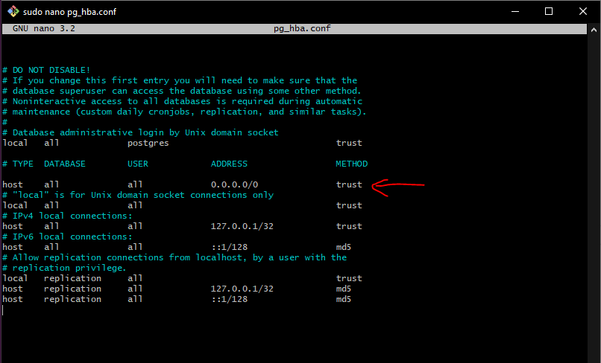

Figure 13. Postgres pg_hba.conf file with changes

After that you should modify postgresql.conf file to match Figure 13. Take note of port number and listen address variables.

*sudo nano /etc/postgresql/12/main/postgresql.conf*

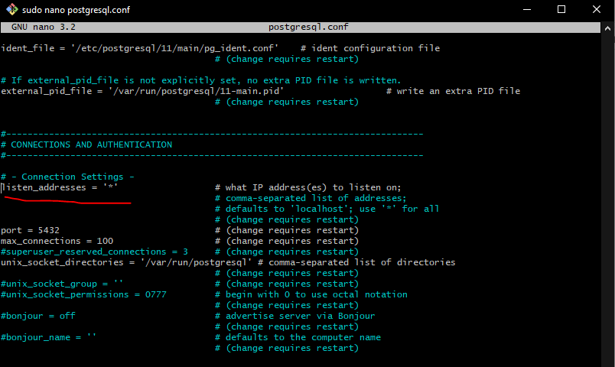

Figure 14. Postgres postgresql.congf file with changes

After changes have been made restart postgres:

*sudo systemctl restart postgresql*

## Creating table in PostgreSQL prompt

1. SSH into virtual server *ssh user@172.16.4.xxx*
2. Access the PostgreSQL prompt *sudo -u postgres psql*
3. Create the database *createdb test_db*
4. Connect to the database *\c test_db*
5. Create the table *create table public.robottidata*

*(value double precision,*

*name text COLLATE pg_catalog."default",*

*quality text COLLATE pg_catalog."default",*

*"time" timestamp without time zone);*

1. Exit psql prompt *\q*

## Creating table in phpPgAdmin

1. Connect from the phpPgAdmin to your database with password and username figure 15.

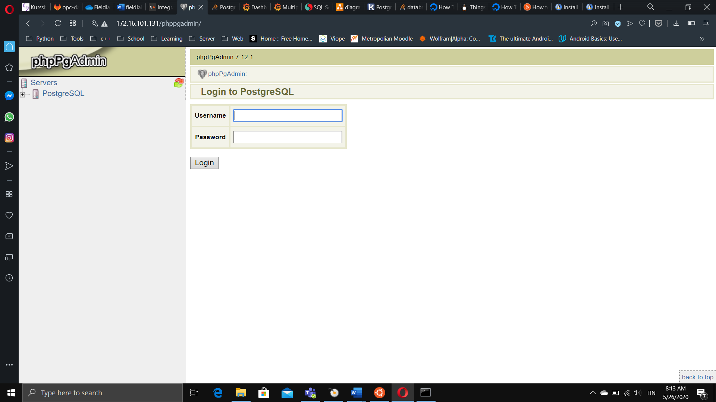

FIGURE 15. Logging into PostgreSQL

1. Create database figure 16.

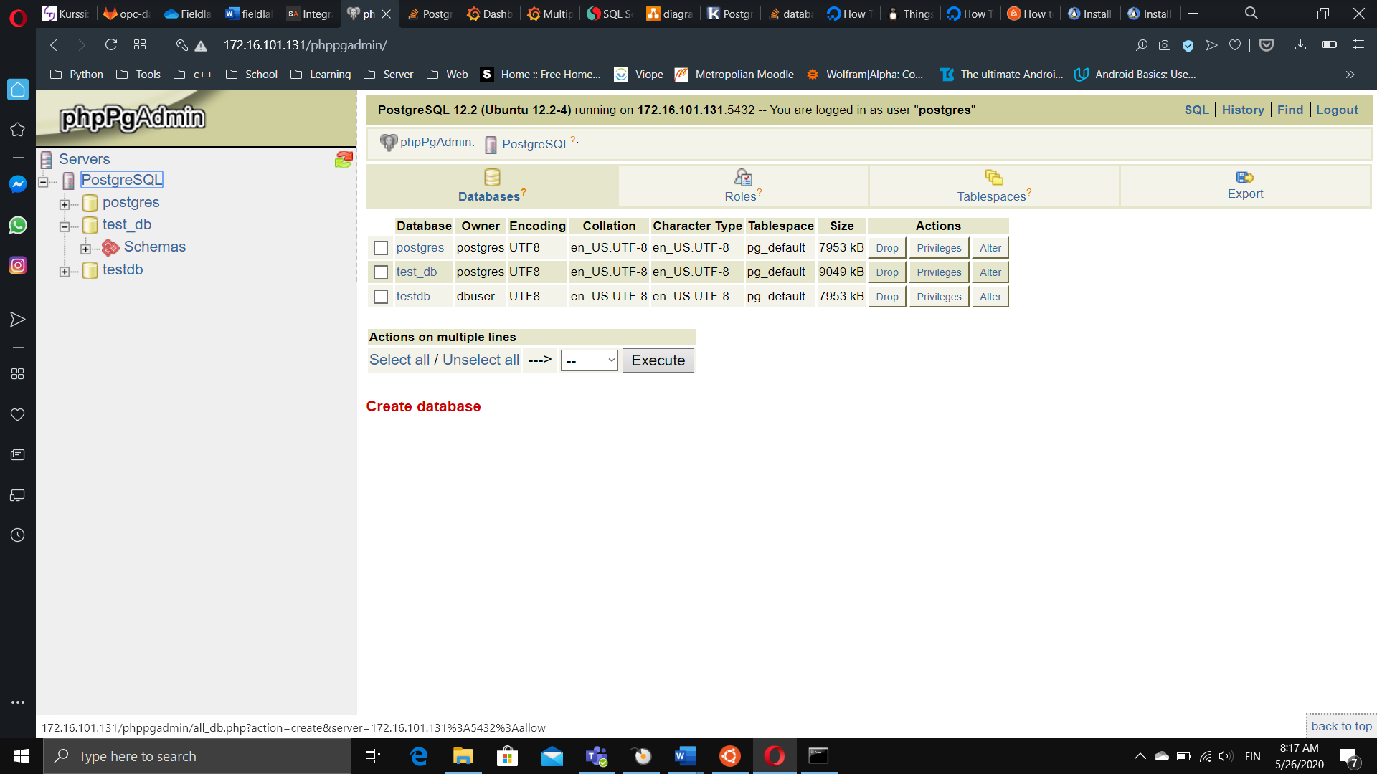

FIGURE 16. Create database

1. Name your database and choose options figure 17.

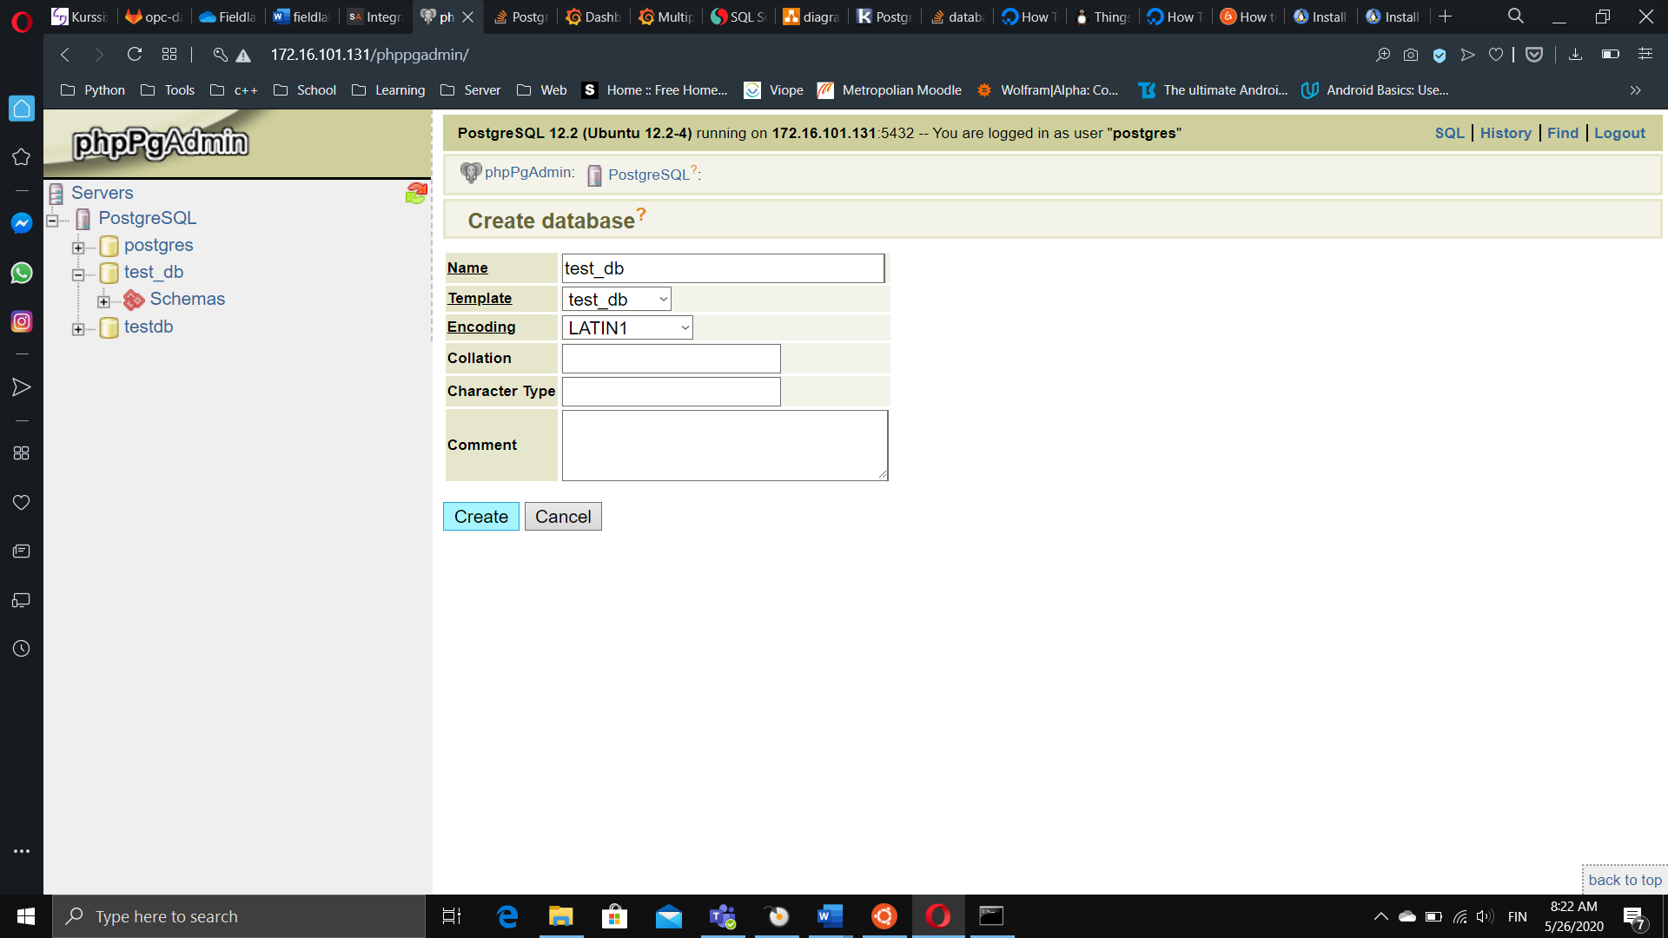

FIGURE 17. Configuring the database

1. Click create.
2. Open your database and create the table (figure 18).

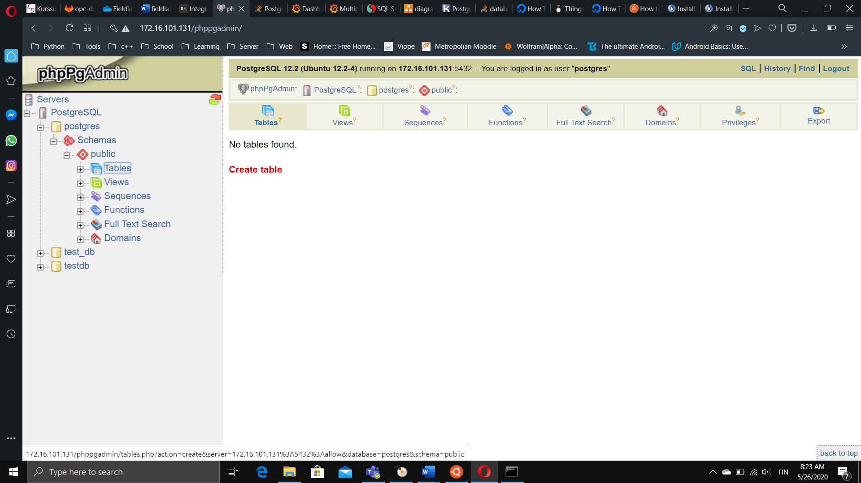

FIGURE 18. Create a table

1. Name your table and decide how many columns does it have (figure 19).

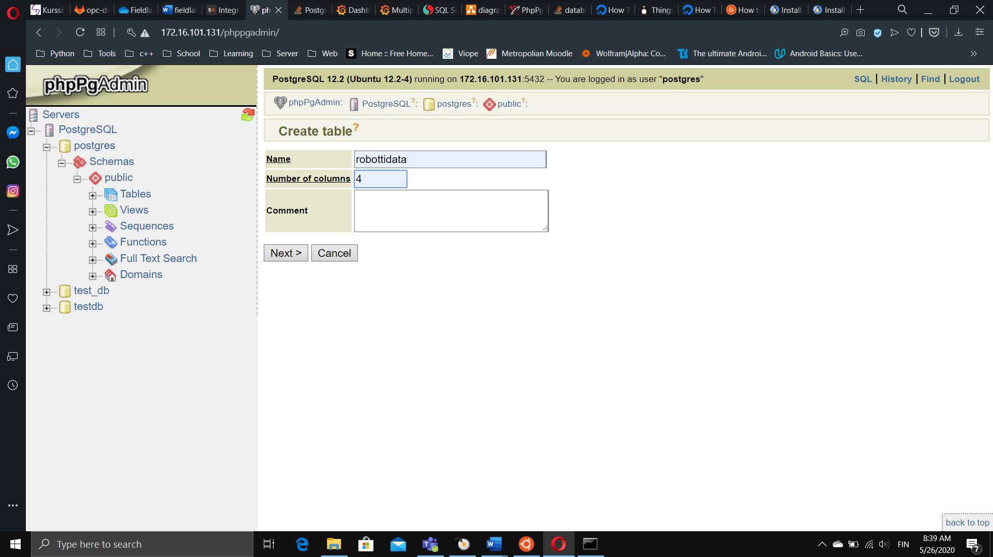

FIGURE 19. Naming a table

1. Name the columns decide their type (figure 20 and 21).

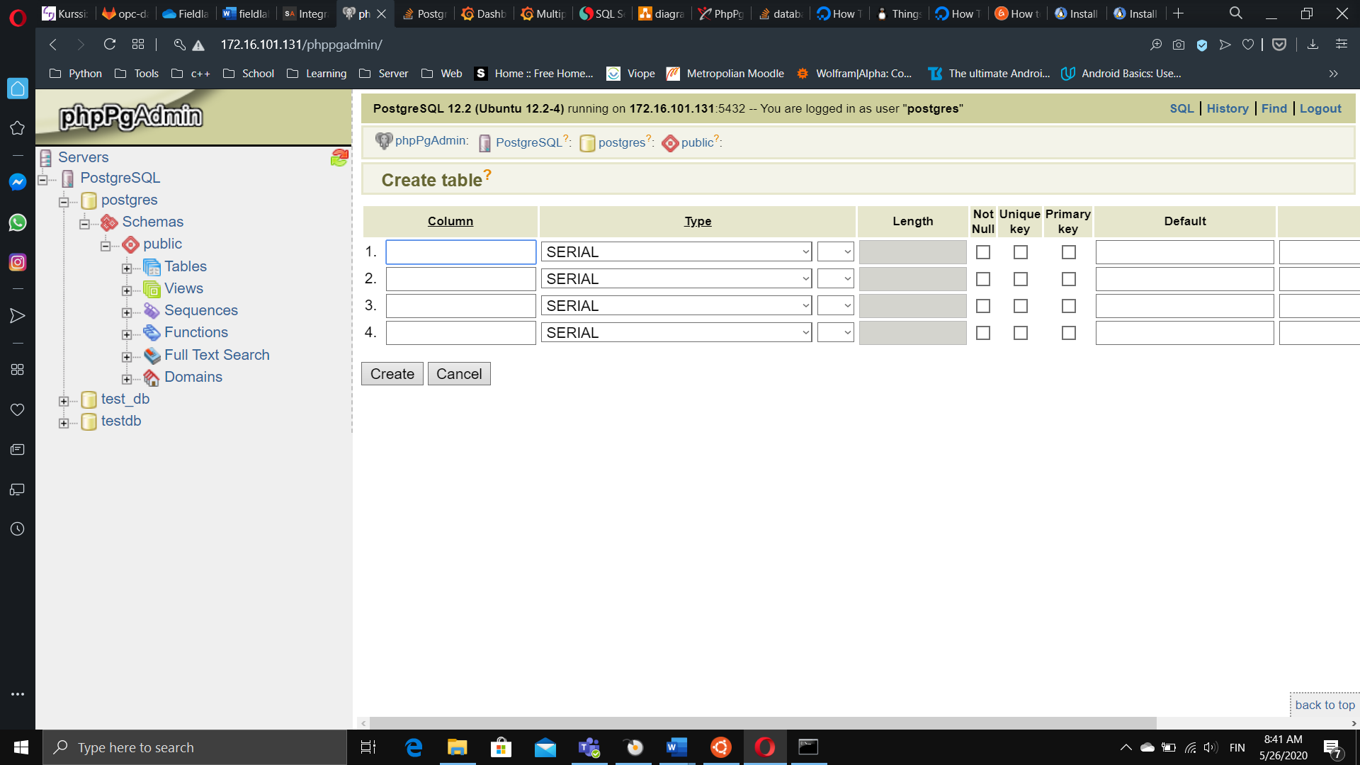

FIGURE 20. Naming table columns

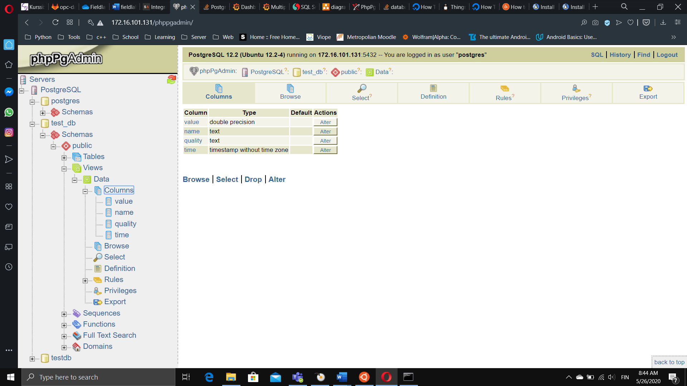

FIGURE 21. Defaults used by the project

# GRAFANA

[Grafana](https://grafana.com/) is a analytics platform for all any metrics, which allows you to query, visualize, alert on and understand you metrics. More information can be found from [Grafana's official documentation](https://grafana.com/docs/grafana/latest/).

## Installing on virtual server

From [computing for geek's article](https://computingforgeeks.com/how-to-install-grafana-on-ubuntu-debian/):

1. Update the system.

*sudo apt update*

1. Add Grafana gpg key which allows you to install signed packages.

*curl https://packages.grafana.com/gpg.key | sudo apt-key add –*

1. Install Grafana apt repository.

*sudo add-apt-repository "deb https://packages.grafana.com/oss/deb stable main"*

1. Install Grafana.

*sudo apt-get -y install Grafana*

1. Start the service

*sudo systemctl enable --now grafana-server*

## Connecting with PostgreSQL

To access Grafana point your web browser to the IP address of your virtual server and port 3000. The default username and password are both admin (figure 22), after which you are required to set new password.

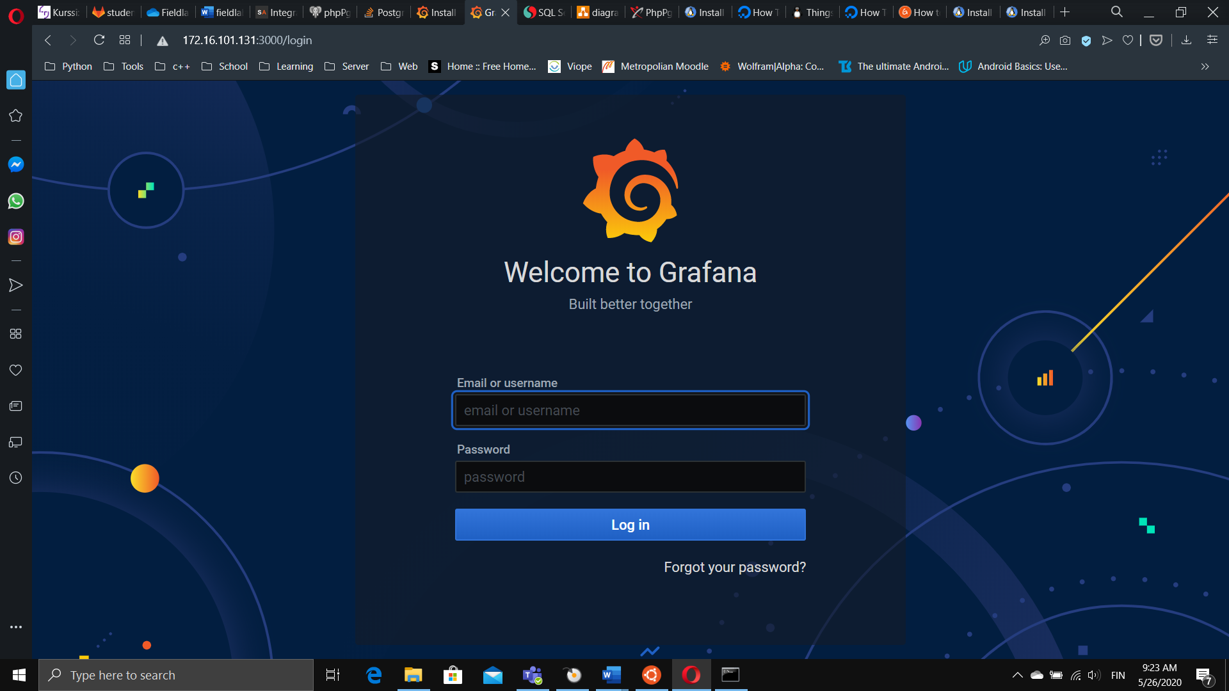

FIGURE 22. Login screen

## Add data source

On the first page you can find the “[Add your first data source](https://grafana.com/docs/grafana/latest/features/datasources/add-a-data-source/)”. It this is not visible, by hovering the mouse over the configuration cog as in figure 23, you can add data source by clicking “Data Sources”.

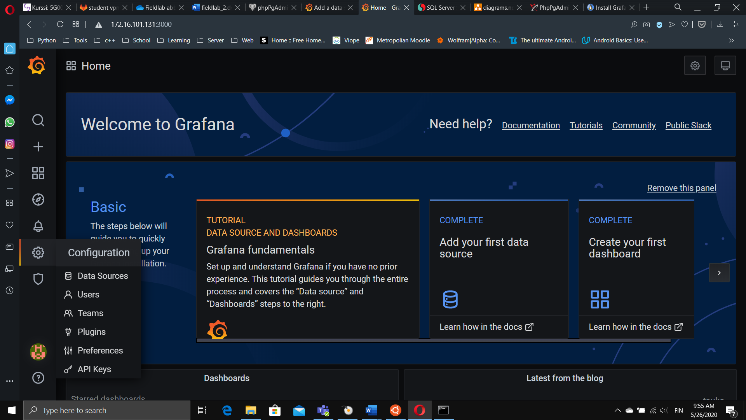

FIGURE 23. Opening the configuration dialog

Add PostgreSQL as a data source (figure 24)

.

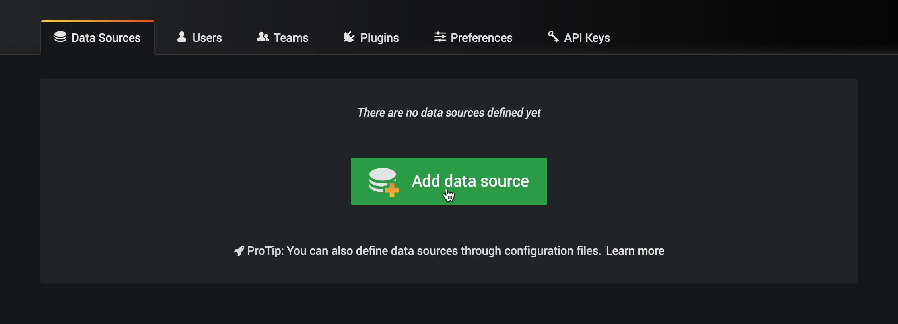

FIGURE 24. Add data source

After selecting PostgreSQL from a list, name your data source, give the IP address and port (5432) in settings seen in figure 25.

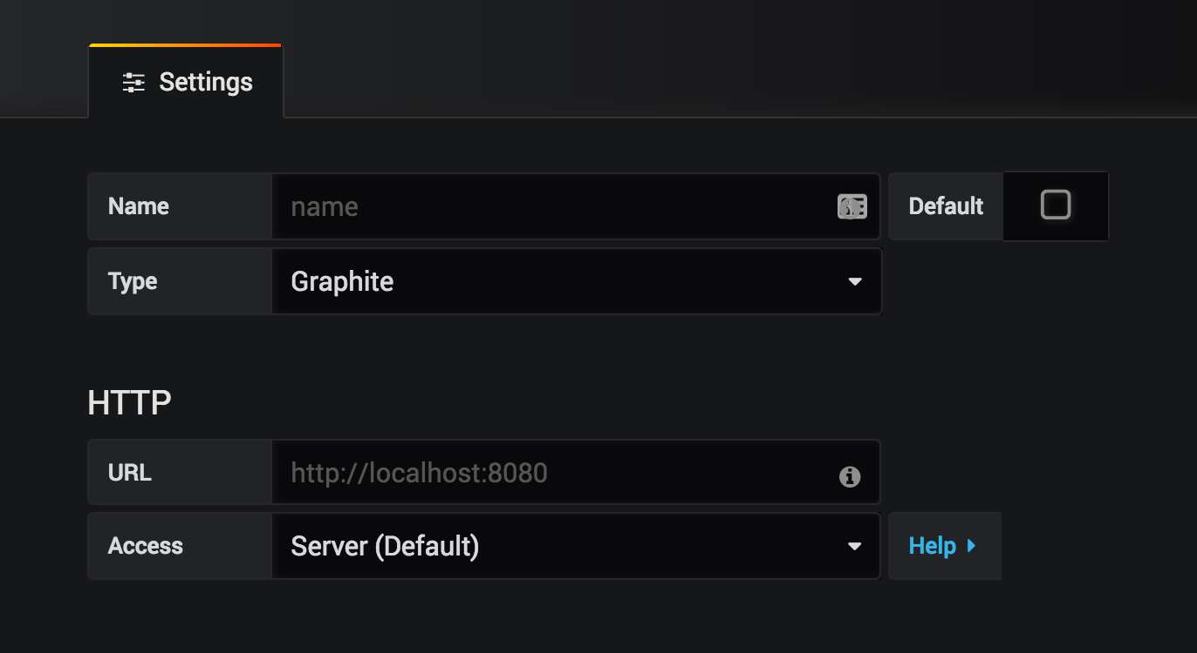

FIGURE 25. Database settings

## Create a dashboard

By hovering the cursor over the ‘+’ sign on left, you can create new dashboard. After which from the top right you can add new panel to the dashboard (figures 26-28).

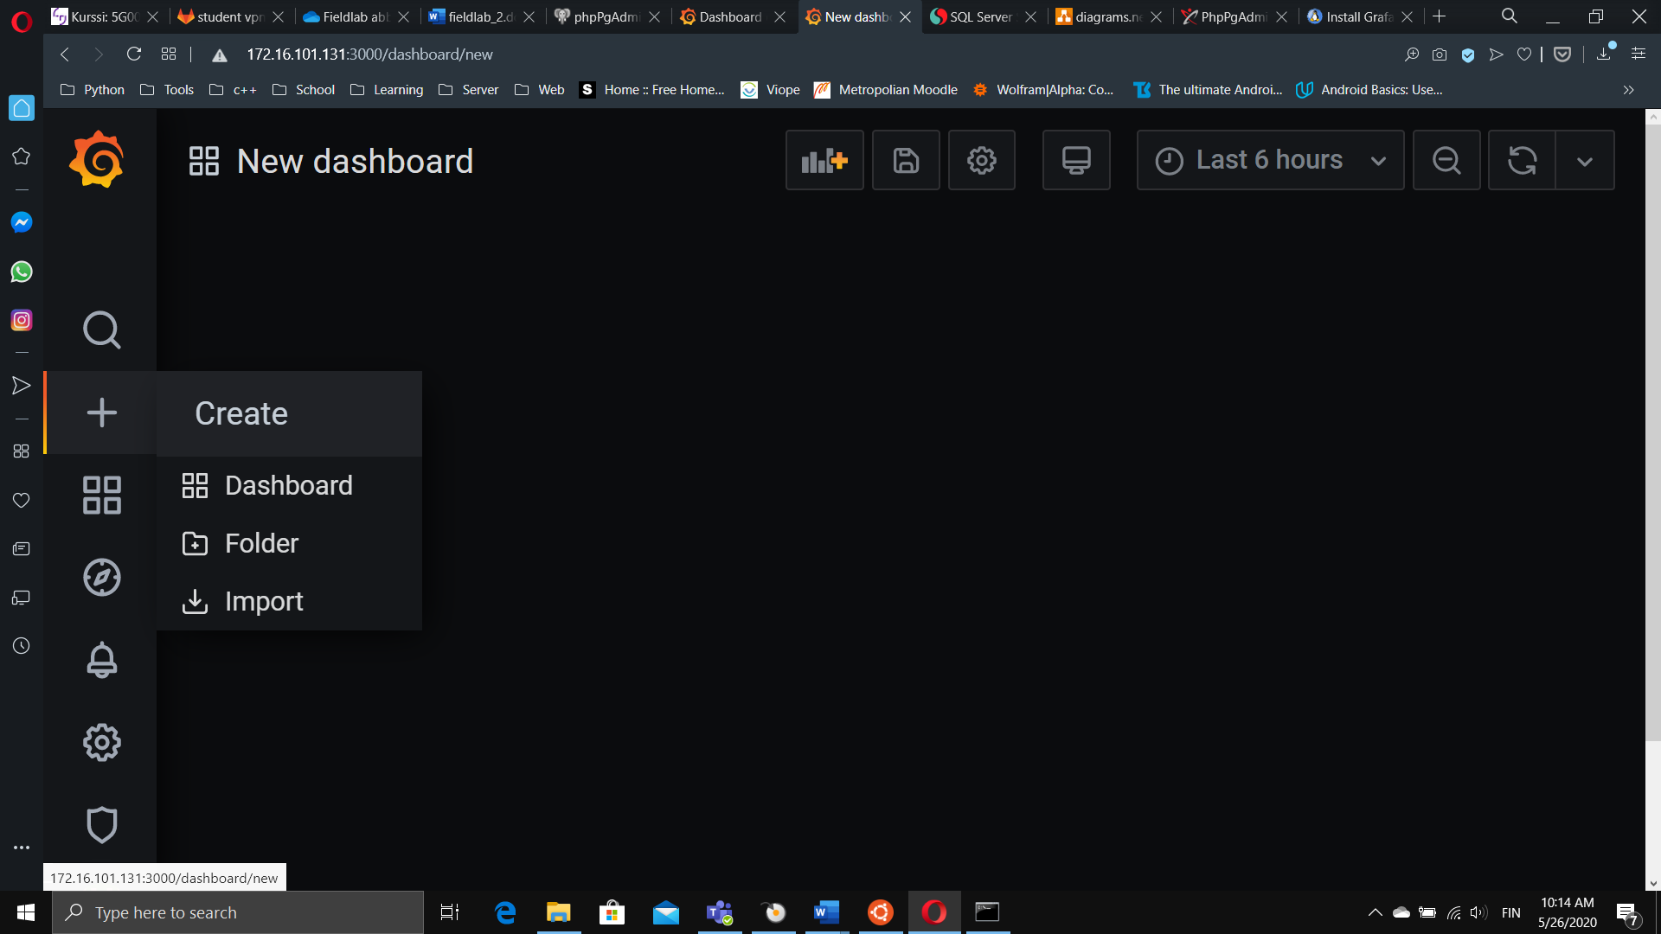

FIGURE 26. Create dialog

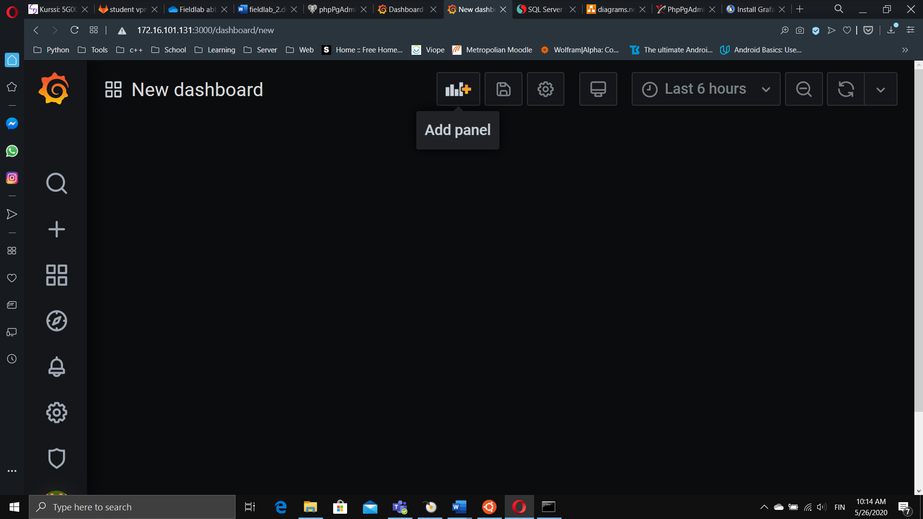

FIGURE 27. New dashboard

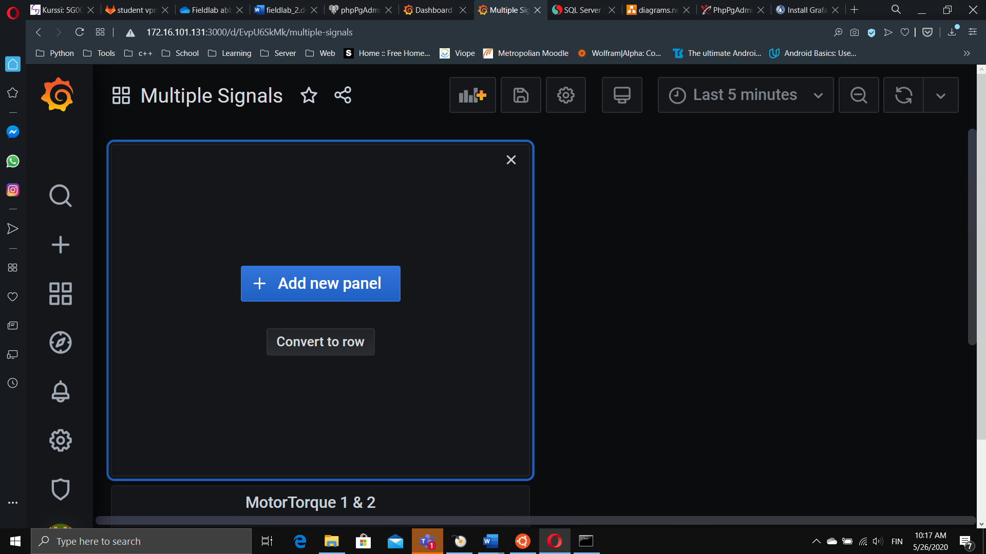

FIGURE 28. Add new panel

After adding new panel you should see something like figure 29.

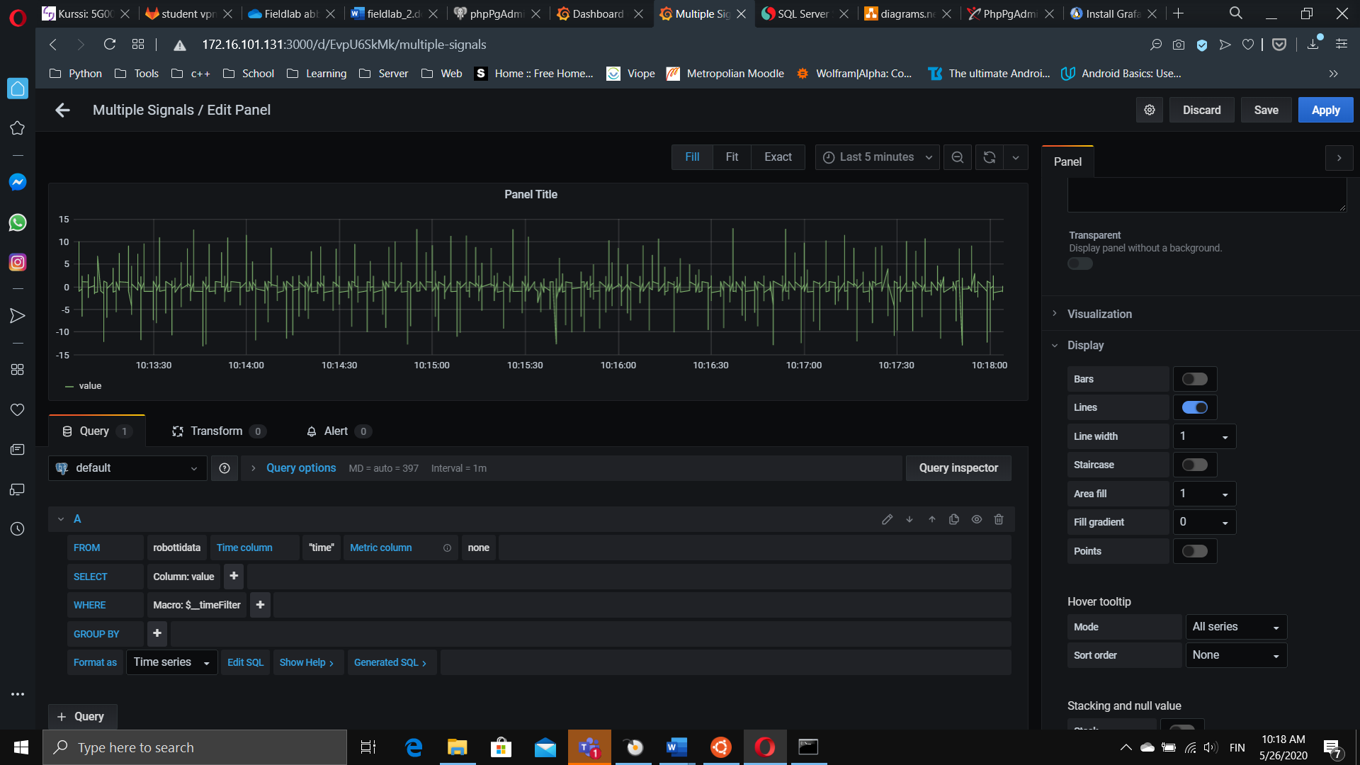

FIGURE 29. Basic view of the new panel

If the connection has been formed, on the lower left quarter of the screen you can see query panel like in figure 30. This tool allows you to make query for your database, which are the basis for every graph created.

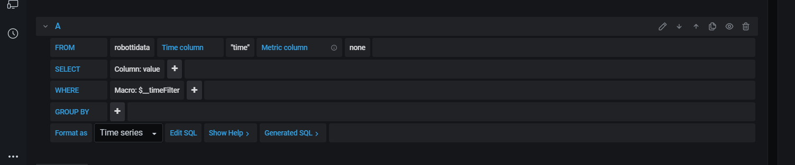

FIGURE 30. Query panel

If you’re using the provided Dataprojekti.rspga file, from metric column you can choose name or quality as in figure 31. Choose name, from where remove the Macro: $__timeFilter by clicking it.

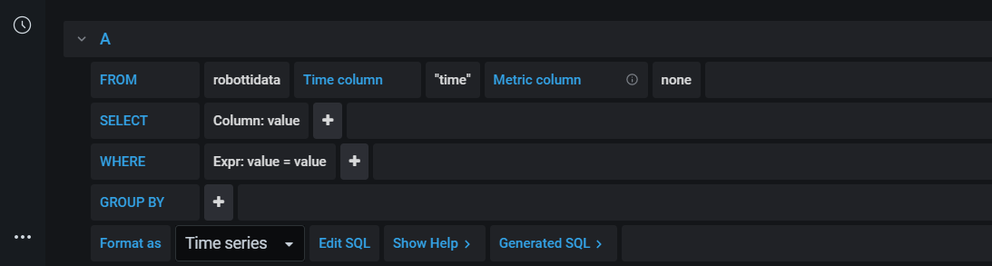

FIGURE 31. Making a query

Then you can add expression, replace the first value from drop-down menu with name and replace the second value from drop-down menu with the signal of you choosing like in figure 32.

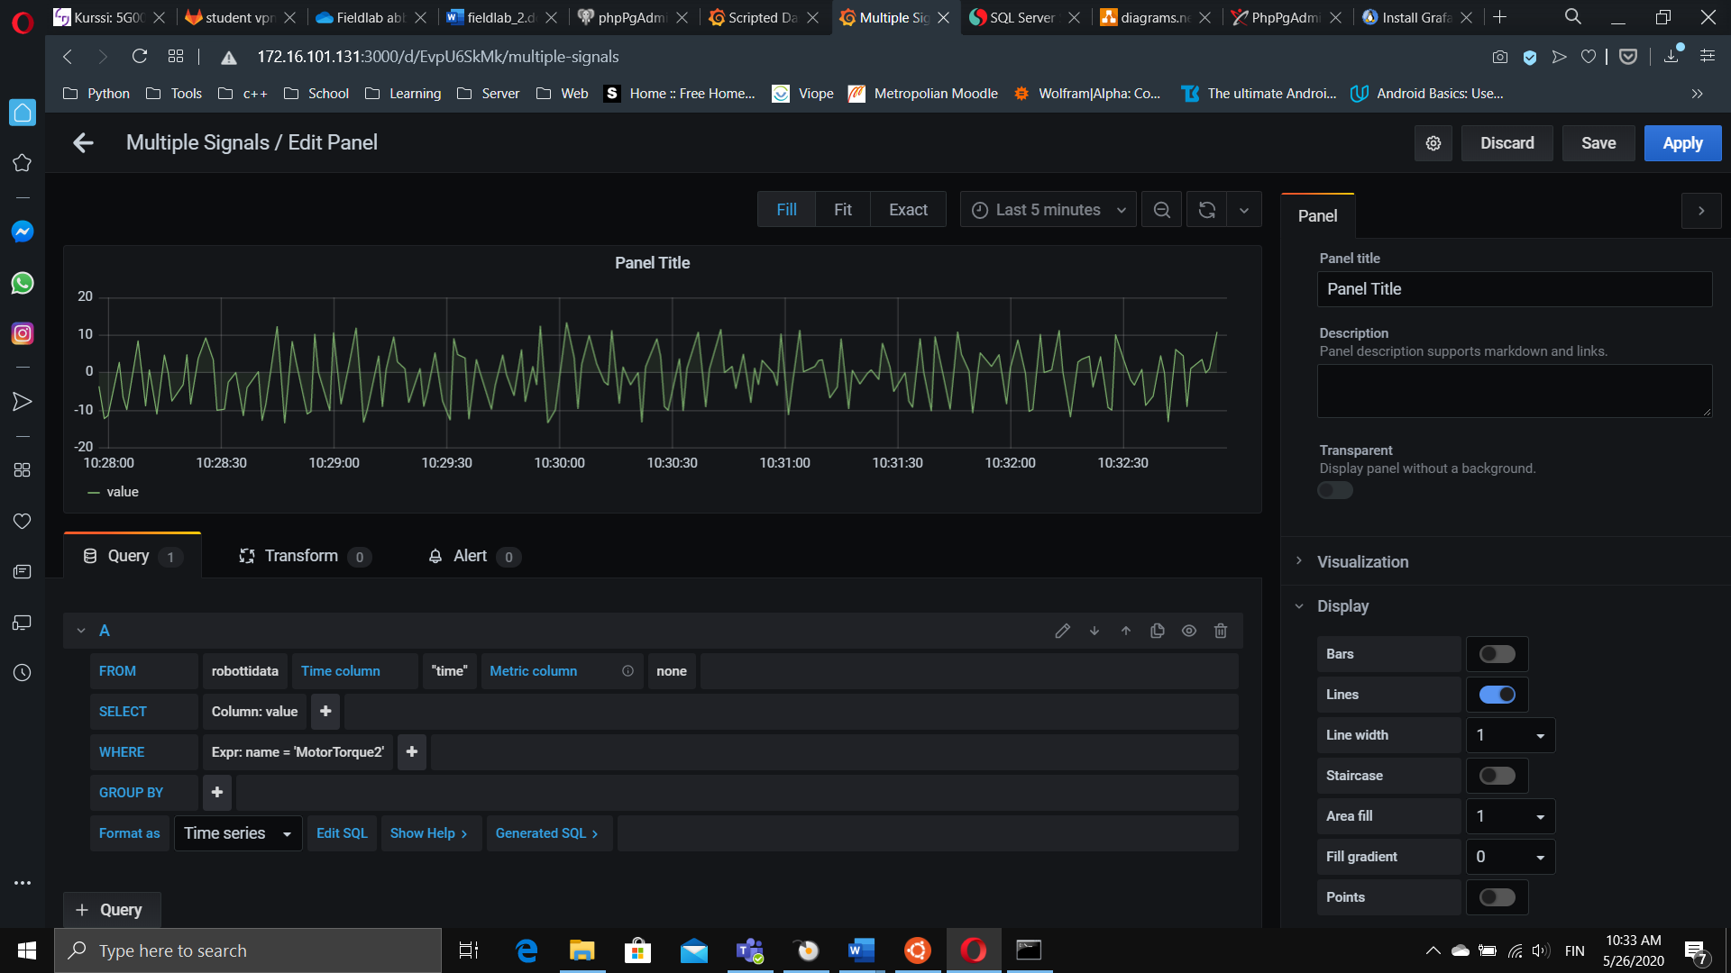

FIGURE 32. Choosing where

Voilá, you have your first graph, just apply it.

# SETTING UP THE REST OF THE VIRTUAL SERVER

## Install the Nodejs back-end

This is the API from which the front-end gets its data from. Before you can install the API, you’ll have to install both Nodejs and npm on the virtual server. Of course these could be run from a docker container, but for simplicity we’re installing the needed packages directly on the virtual server

1. Update the system sudo apt update
2. Install the Nodejs package sudo apt install nodejs
3. Check the install nodejs -v
4. Install the npm package sudo apt install npm

Take note! The packages available from the Ubuntu repositories are a bit older, but still adequate enough for this project. If you want something more bleeding edge, you could follow these instructions from [DigitalOcean](https://www.digitalocean.com/community/tutorials/how-to-install-node-js-on-ubuntu-20-04).

Before running the API you should check the following files and modify them accordingly since they contain references for the database used (figures 33 and 34):

*/node-back/app/config/db.config.js*

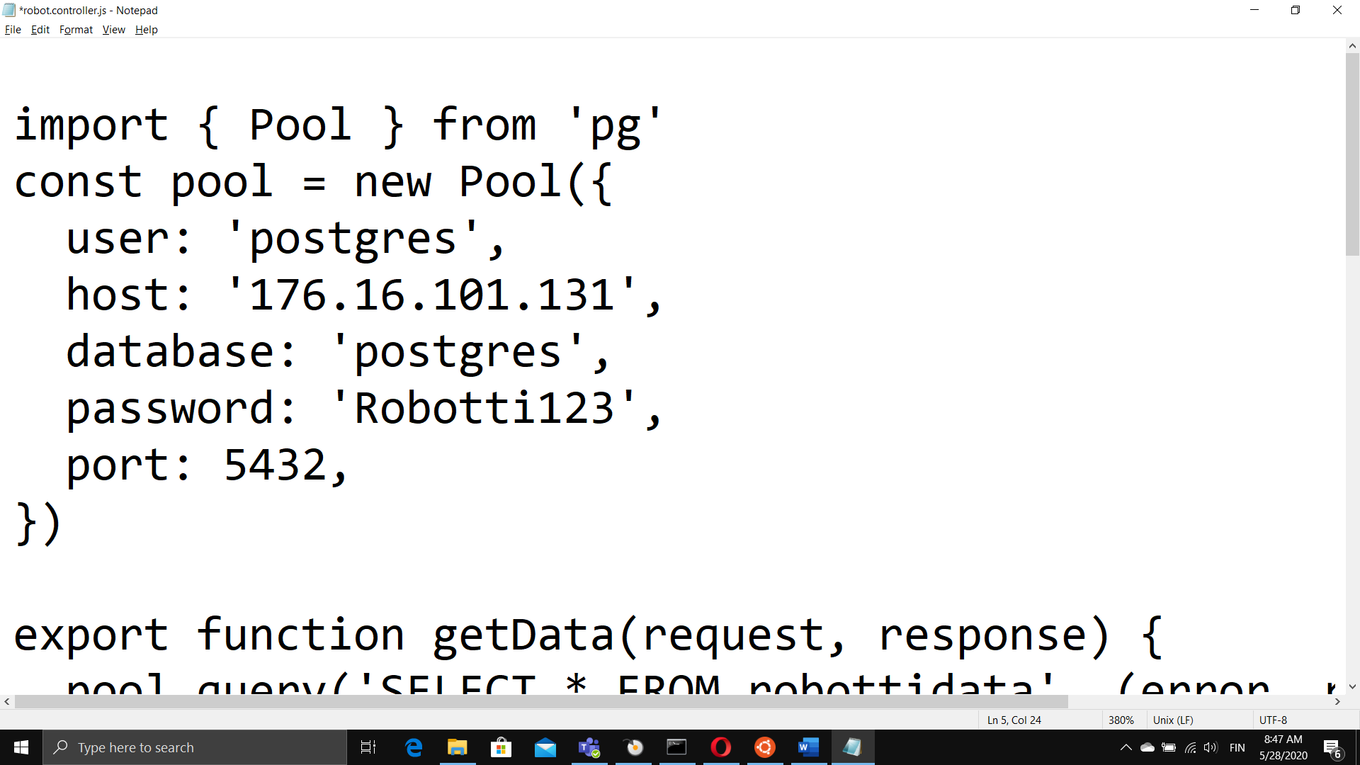

FIGURE 33. db_config.js

/node-back/app/controllers/robot.controller.js

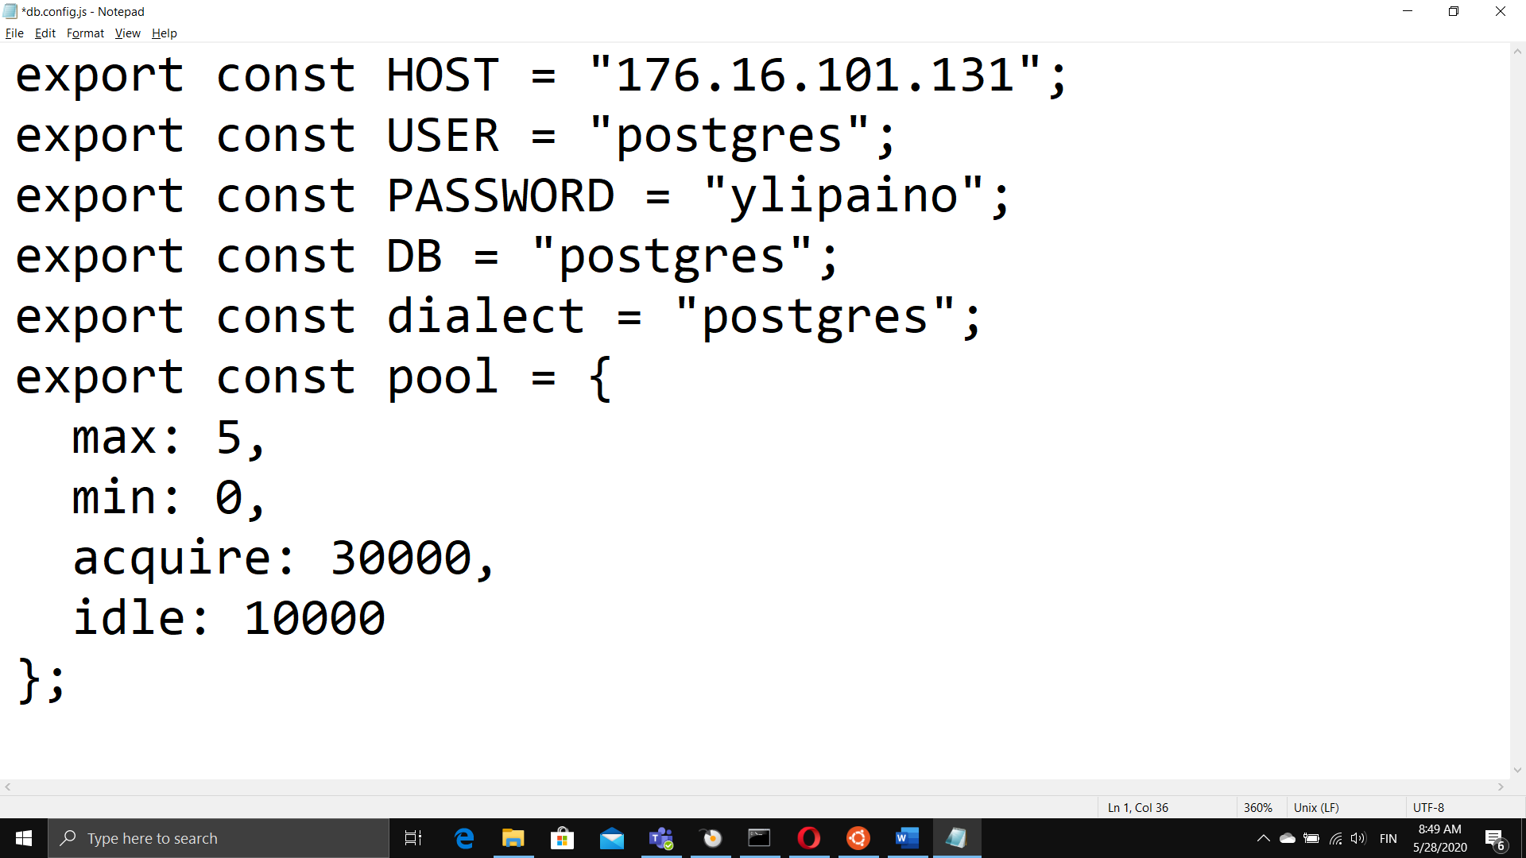

FIGURE 34. robot.controller.js

Next you can install the projects API from the node-back folder.

1. Navigate to the node-back folder *cd /home/project/node-back*
2. Install the project *npm install*
3. Start the API *node start*
4. Check in your browser [*http://172.xx.xxx.101:8080*](http://172.xx.xxx.101:8080)

After which you should be able to receive message ‘hello’ from your API. In order to make your API run continuously in the background, we’ll install [pm2](https://www.npmjs.com/package/pm2) while still in node-back folder:

1. Install the pm2 application *npm install pm2 -g*
2. Add the API to pm2 *pm2 start start.js*
3. To stop the API *pm2 stop start.js*
4. To restart the API *pm2 restart start.js*
5. To check API [*http://172.xx.xxx.101:8080/api/robots*](http://172.xx.xxx.101:8080/api/robots)
6. To create startup script *pm2 startup*

## Install the React front-end

The front-end is responsible for presenting the data received through Nodejs back-end. Before you can install anything on to the virtual server, you’ll have edit the following file and modify the IP address like in figure 35:

*/react-front/src/contexts/DataContext.js*

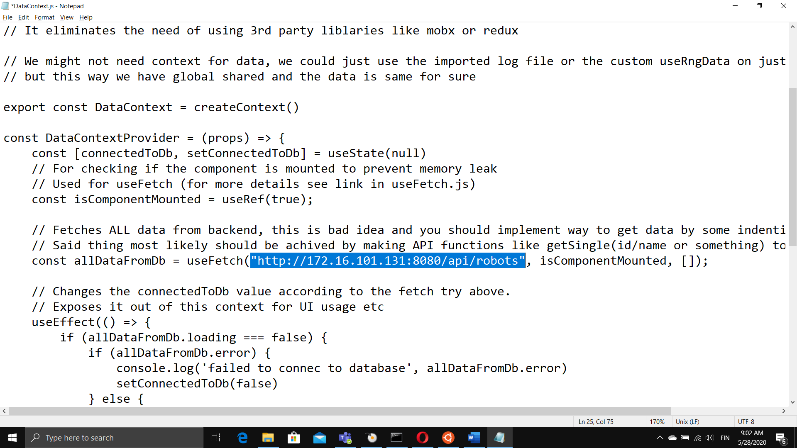

FIGURE 35. DataContexts.js

Depending on the directory you’re installing the package, you’ll have to alter theownership of the folder /react-front as in steps 1 and 2.

To test the front-end:

1. Navigate to the project folder *cd /home/project/*
2. Alter the ownership of /react-front

*sudo chown -R myuser:mygroup otherfiles*

* The myuser is the name you use to login
* To find mygroup, type: *id -ng*

1. Navigate to the react-front folder *cd /home/project/react-front*
2. Install the project *npm install*
3. Start the API *npm start*
4. Check in your browser [*http://172.xx.xxx.101:8080*](http://172.xx.xxx.101:8080)

To build a production version, which can be run on Apache2 server pre-installed on virtual servers, you’ll need to:

1. Navigate to the react-front folder *cd /home/project/react-front*
2. Build the project *npm run build*
3. Navigate to the build folder *cd /react-front/build*
4. Copy the content to /var/www *sudo cp -r * /var/www/html*
5. Restart the Apache2 server

*sudo systemctl restart apache2.service*

Now the front-end should be running on your virtual machine.

To learn more about the build process and Apache server:

[How to install Apache on Ubuntu 20.04 LTS](https://www.cyberciti.biz/faq/how-to-install-apache-on-ubuntu-20-04-lts/)

[React documentation](https://reactjs.org/docs/getting-started.html)

### Technologies used

Framework: React

<https://reactjs.org/>

Stylesheet used: SCSS.

<https://sass-lang.com/>

Coded with: VS Code – repository might contain config files for VS Code.

UI components built with material-ui library and layout done with CSS Grid.

<https://material-ui.com/>

<https://developer.mozilla.org/en-US/docs/Web/CSS/CSS_Grid_Layout>

<https://css-tricks.com/snippets/css/complete-guide-grid/>

Charts use the Victory library:

<https://formidable.com/open-source/victory/docs/victory-chart/>

<https://github.com/FormidableLabs/victory-chart/>

### Points to consider from the original team

We recommend Visual Studio Code for your code editor.

Tip: you can use Vs Code's terminal (opens with ctrl+ö or Ctrl+`) to run commands like the ones used in installation progress.

When working with styling it is recommended with reusable components and variables(colors) that they are created in react-front/styles/components or a folder equivalent to that to avoid repeating code.

Always remember when making a new global .scss file to add it to index.scss file: @import ‘new_file.scss’.

When making new charts it is recommended that you add them in the MainPageCharts.js file into the chartsArray-array for automatical mapping. Using the Victory documentation, you can make and modify charts in many ways.

The code is written using React functional component with Hooks. Using functional components and hooks is not required, any kind of React works but it can be argued to be the future of React.

If you don’t have much experience in React, you can read React’s own site but a good way to learn is The Net Ninja’s YouTube playlist. There is React Context & Hooks Tutorial and a general React tutorial linked in the sources of this document.

# FURTHER DEVELOPMENT

## OPC Server and Python connection

NodeRed would seem like a good further development opportunity to replace Python. NodeRed was abandoned due to connection problems because our robot's OPC server uses the DA protocol.

## Database/server

Database could use more cURL functions, such as search by date/time with start and end times. Add functionality to select single class of data such as “motortorque 6” from database to front, so all data is not sent when asking for single data.

## Frontend

There are many ways to use Victory to display the data. Consider a method to display data that is not continuous, which can be most of the data, so that it only displays relevant values in an easy to read way. Activity data for example doesn’t seem to be readily available and you need to come up with a logic that displays the active time of the robot in question, if activity is a metric that you wish to display. That being said the demo charts are no means ready and might be implemented wrongly so I’d advice to dig deeper into the Victory library and look for examples online and read the official documents.

As stated in Database/server section, right now, the frontend can only receive all data as bulk. Backend needs to expose frontend a way to request a single set of data like motortorque6.

What our application lacks now is continuous subscription of data from database to frontend. Database gets new data as it comes from OPC. But frontend isn’t aware of new changes unless you add real-time subscription with web-socket.

Working with database people is essential in order to have the data stored in a way you think is easily fetched and used.

In short frontend needs real-time data subscription and the charts needs to be made compatible with incoming data.

# Current Front-end

## Main page

Main page has currently four variables that store data. AllGraphsData has data of all the chosen signals for each of the four charts.

Options variable has other relative info to each chart, and it is updated in options function. It consists of things like id of graph, names of the signals, label for chart y-axis based on unit type the signals have and the number of different signals in chart.

newDataFromDb is the data where charts signals get filtered from currently. Goal is to make it so that this data gets pre filtered so that it isn’t fetched as bulk.

Next are main page functions positiondata() and useMemo().

Positiondata function has older function name and it will be updated later date. This function updates data in allGraphsData based on chart id in options currently.

useMemo() function is react hook which makes it possible to react changes in function after render. This useMemo reacts to changes in options variable. After options have been updated then newDataFromDb will be filtered based on signal names on options variable. After filtering signals from data bulk then positiondata is called and allGrapshData is updated.

Main page returns main parts of web server. It calls following functions inside div: NavBar, DataSearchBar, OptionsBar and ChartsContainer where different charts will be collected. Currently max number of different charts that can be shown same time is 4.

## DataContext

This component is responsible of fetching data trough api from database and holding it. It also changes the value types in fetched data from string to numeric and also makes 3d data value possible to use. Datacontext makes it possible for every component to use its data without the need to pass its values down trough call tree. There are also statevariables dataTable and filterState which are used in DataSearchBar component. There they are updated every time user wants to fetch data from new table. Data is fetched by using customhook component useFetch().

## useFetch

This is currently the only customhook that is used in the project. It uses reats useEffect component which checks every time when its parameter url or ref changes. If either of those has changes then it will execute function. In function it first checks that some change has happened in page (this is what ref value refences) and that filterState is false which means that user has picked other table contents to be fetched form database. It will then fetch data and put it in data state value. It will also update filterState back to its default value which is true.

## NavBar

Navbar is component which is the upper most in web page. It contains connection status and the Fieldlab header. There are left some event handlers for popover events if those are needed/wanted at later date. Only real thing it actually does currenty is inform if data fetch was possible by telling if table connection is connected or offline.

## DataSearchBar

This component is the next uppermost part in webpage. It is used to allow user choose which datatable contents from database will be observed. Currently two options: option 1 is hardcoded list of datatables that user can choose from and it requires updating every time new table is added to database. Option 2 is allowing user to give table name as input and try getting data with said parameter. This datatable selection could be moved to navbar component.

## OptionsBar

Optionsbar contains the two separate dropdown selections which are filter panel and signal selection panel. It uses @material-ui/core librarys expansionpanel component. This file also has state function to get data from Optionsfilter component to Options component. UseEffect function is used to empty state function when new table form database has been fetched. This is done so old filter data wont remain to cludder Options component.

### OptionsFilter

This is the component where user can filter which signals can be chosen. It gets all the unique properties which can be used as filter from datacontext component. Rebuildlist() function is used to create object that follows certain logic and the logic is presented in following picture.

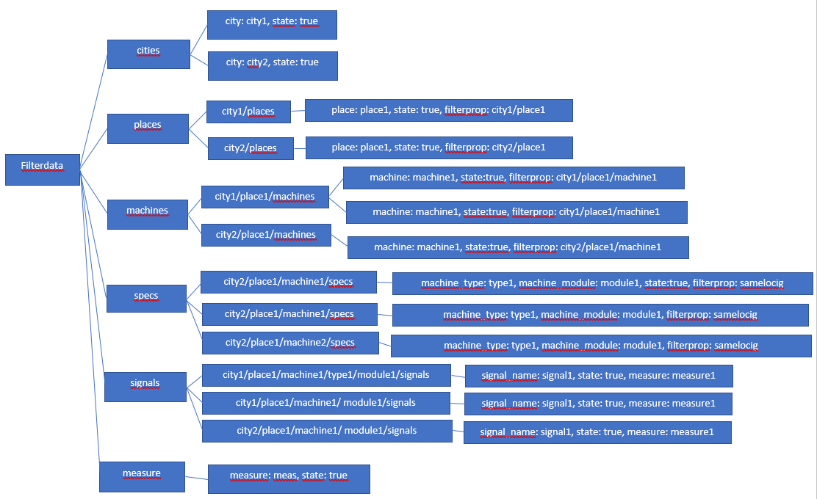

The idea is that each category gets its own branch. At the end of the branch theres usually branches value, state and its “path” which is used later in code to find right value. In function it goes trough each category and creates these unique branches that way by filtering out non unique combinations.

sendfilterdata() function goes through whole filterdata object and checks which signals have state:true. Those signals will then be put on new list and sent to Options component.

statemanager() function is used to update each values state. Whenever user clicks checkbox in one of categories values it will update filterdata object. It is made also in a way that if user unchecks something like city then all lower categories and signals in the chain will be unchecked too

Divlist() function is used to divide category in separate divs so its easier for user to see for example which places are under city1 and which places are under city2.

This function will ultimately return html for the panel which shows six category divs where there are values to choose from.

### options

This component is used to send chosen signals to mainpage component where data is then filtered based on those signals. That data is then used to make charts. This component gets its filtered signals from Optionsfilter component. First it creates new list where signals are sorted under each unique filter combination. Apply() function goes trough new list and picks the signals which has state: true. Those are then put in chosenoptions object which is then sent to mainpage. Depending on if user wants to use two axis chart then there will be two unique lists and chosen options has then two different sets of options for each axis.

### signalbox

This component is used to list signals in divs so user chan pick which signal data they would like to see visualized. It has checkboxclick() function which updates signal state. Names() function creates each signal its own div. This function returns one or two divs worth of signals as html.

## ChartsContainer

This component holds all the created chart components where data is visualized. There are some parts commented out because they aren’t currently needed. They are used to have popover function. Meaningful parts are chart function and what component returns.

## BasicLineChart

This component has calls for all the other basicchart components and returns typical chart where data is visualized. First function turns time string to milliseconds so that x-axis can be dynamically scaled. Then it has state objects for axis1, axis2 and timeaxis. Unique function is for making new unique copy from data object. Zeros() function counts how many zeros are in y-axis value, this is used in scaling y-axis values. Tick function is used to calculate even tick value between max and min values in y-axis. Axisvalues() function initializes y-axis values in a way that min is lowest signal value and max is highest signal value from all chosen signals. Getdeftime() function gets the starting point in time and ending point in time from all chosen signals. default_time variable is used as the time point where to return when user chooses default values. Usememo() is react function which allows updating chart values when chosen signal data changes. functions is just easier way to pass down set of functions in one function. Default1 and default2 are default values for both y-axis so user can return back to those values if they so choose. This component returns visualization of datachart with either one or two y-axis.

### SingleOptions and MultiOptions

Both of these components are used to make changing axis values in chart possible. SingleOptions is for one y-axis chart and multioptions is for two y-axis chart. Both of these components have functions for updating y-axis max, min and tick value. They also have option to change time span but it might be obsolete currently because of visualized scale chart that you can use to change the span of time. Once user chooses different values and accepts them then those values are used in SingleAxis component and MultiAxis component. Both of these component show as upmost panel in chart.

### SingleAxis and MultiAxis

These components are responsible of the visualised part of the chart. It builds axis and lines based on data. timetoSeconds() function works the same way as in main BasicLineChart. secondsToTime() function changes milliseconds back to readable time string which will be shown in chart. timecheck() function is used to divide timespan to equal size tics. setTickValues() function creates list of y-axis value ticks which will be shown in the axis. timeStampToMills is used to pick data and change timestamp into HH:MM:SS:SSS form. timeinterval() function does same as setTickValues but for time axis. Both singleAxis and multiAxis component return visualized datachart.

### BasicInfo

This component shows the names of the chosen signals and their respective colour on the displayed chart.

## MultiDimChart

This is component used to make 3 dimensional chart. It currently only shows given data in three axis and doesn’t do anything special. It uses same data as BasicLineChart but it can only take signals from signals list 1.

# Current Back-end

Back-end is currently really simple and should be developed more.

### robot.controller

This file contains the endpoint sql functions. Currently there are 2 functions, one for all data and one for getting all filterdata. getrealdata() is used to get all data from table that is given in http request. Getrealfilter() is used to get all distinct values for properties city, place, machine, machine_type, machine_module, signal_name, signal_number and signal_unit. This file also has the server connection info.

### robot.routes

This file contains the api http method functions and url paths.

# SOURCES

OPC DA | PYTHON | SERVER | CLIENT

<https://www.youtube.com/watch?v=lbubVMlPP6Y>

OpenOPC for Python

<http://openopc.sourceforge.net/>

Python ohjelmointikieli

<https://www.python.org/about/>

Python opiskelua (perusteet)

<https://www.learnpython.org/>

OPC DA Auto Wrapper

<http://gray-box.net/daawrapper.php?lang=en>

React Tutorial Playlist by The Net Ninja

<https://www.youtube.com/watch?v=yZ0f1Apb5CU&list=PL4cUxeGkcC9i0_2FF-WhtRIfIJ1lXlTZR>

React Context & Hook Tutorial

<https://www.youtube.com/watch?v=6RhOzQciVwI&list=PL4cUxeGkcC9hNokByJilPg5g9m2APUePI>

Websocket tutorial examples

<https://www.smashingmagazine.com/2019/03/realtime-charts-graphql-postgres/>

<https://www.graphql.college/graphql-subscriptions-with-react-node-apollo-and-postgres/>

Front and back gitlab repository

<https://gitlab.tamk.cloud/tamk-projects/robot-innovation-project>

ATTACHMENTS

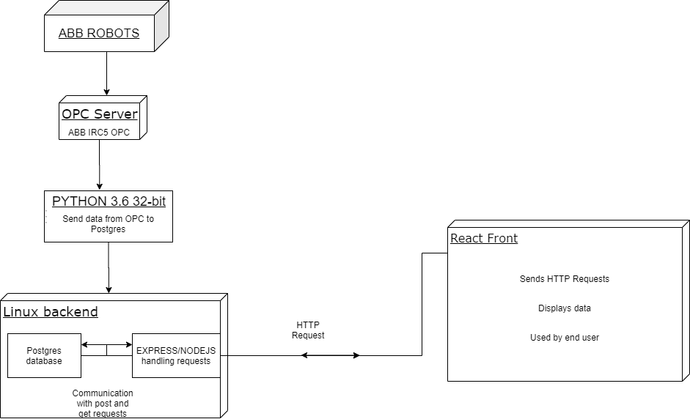

Architectural diagram of project